Professor Mark Sutton

University of the Islands

27 Island Way

Scotland

UK

nitrosorted@ui.ac.uk

‘Towards INMS’ Project

International Nitrogen Initiative

NERC Centre for Ecology and Hydrology

Bush Estate

Penicuik

EH26 0QB

United Kingdom

8th June 2015

Dear Professor Sutton

**Subject: Letter of commitment and co-financing confirmation for the ‘Towards INMS’ project**

As the regional director of the University of the Islands, I would like to express our strong support to the ‘Towards INMS’ project and our interest in becoming involved. Our organisation is greatly interested in the development of a science-policy support process, to enable the more effective management of nitrogen whilst minimising the environmental impact.

We envisage our co-financing support to the project in the following areas:

* Activity 1.5: Flux-impact path models for assessment, scenarios & strategy evaluation – [Future model development of the ‘Nitrosorted’ model, 600,000 USD, in-cash support].
* Activity 1.6: Examination of the barriers achieving to better nitrogen management – [Engagement with our stakeholders, through other projects, 200,000USD in-kind support].

We look forward to enhancing the understanding in this key area, in collaboration with all the partners of the ‘Towards INMS’ project.

Yours sincerely

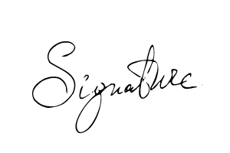

Professor Hilde Ness