INMS Project
GEF FULL SIZE PROJECT DOCUMENT
Appendix 16
Component 2: Global quantification of N flows,
threats & benefits

Table of Contents
1 Component Identification 4
1.1 Component Summary 4
1.2 Links with other Components 5
2 Component Design 5
2.1 Background and context 5
2.2 Baseline 8
2.2.1 Baseline analysis 8
2.2.2 Gaps 11
2.2.3 Stakeholder analysis 12
2.3 Overall objective and outcome 13
2.4 Outputs and activities 14
2.4.1 Activity 2.1 : Quantifying N flows, threats and benefits at global and regional scales 14
2.4.2 Activity 2.2: Preparation of global assessment of N fluxes, pathways and impacts assimilating lessons from the regional demonstrations 18
2.4.3 Activity 2.3: Integrating methods, measures & good practices to address issues of excess & insufficient reactive nitrogen 22
2.4.4 Activity 2.4: Exploration of future N storylines & scenarios with management/ mitigation options & cost-benefit analysis 27
2.4.5 Activity 2.5: Collation & synthesis of knowledge, experience & measures adopted by GEF and others on excess & insufficient reactive nitrogen 31
2.5 Budget 33
2.5.1 GEF Budget 33
2.5.2 Co-financing 36
2.6 Component work-plan and timeline 36
2.6.1 Timeline 36
2.6.2 Activity Work-plans 36
2.7 Execution arrangements 40
2.8 Component M&E 40
Annex 1 – Component Results Framework 44
Annex 2 - Terms of Reference for Partners and Consultants 46

Mission Statement
“To improve the understanding of the global and regional N cycle and investigate practices and policies to maximise sustainable production of food, goods and energy while reducing negative impacts of reactive nitrogen on the environment and human health.”

Component Identification

Component Summary

The aim of this component is to apply tools, methods and data to synthesize knowledge on nitrogen flows, threats and benefits in the context of the global nitrogen cycle. It will apply key inputs in the form of tools and methods developed in Component 1, together with outcomes from the regional demonstration activities of Component 3, to analyse the current status of N flows, threats and benefits. While the first target is the global scale, it will necessarily use the regional activities to illustrate regional variation in context as well as the possible solutions. Options for improved nitrogen management in different contexts will consider the multiple benefits, linking water, air, greenhouse balance, ecosystems and soils, as well as the interactions with food and energy. These elements will inform the development of storylines and scenarios of different “nitrogen futures” and how these relate to cost-benefit analysis. The work will provide key high-level outputs that will support awareness raising and knowledge sharing of Component 4. The targeted research of Component 3 therefore will help develop global policy framing for nitrogen, providing an improved basis for transformational actions on nitrogen management, globally and regionally.
The main elements are as follows:
1) Application of a suite of modelling tools to quantify nitrogen flows, threats and benefits at global and regional scales, including developing a shared database of inputs and model outcomes, provision of international support for regional inventory and model development, and integrated analysis to quantify present and future threats and benefits.
2) Preparation of a first global assessment of N fluxes, pathways and impacts, assimilating lessons from the regional demonstrations, including: scoping the structure of the consolidated global assessment, commissioning author teams, drafting and peer review, preparation of summary documents and review, publishing and distribution of the consolidated assessment. The work will draw on the outcomes of Components 1 and 3, while providing material to support the actions of Component 4.
3) Integrating methods, measures and good practices to address issues of excess and insufficient reactive nitrogen, including preparation of a document on the state-of-the-art for good nitrogen management, considering different N forms and N effects. It will include workshops to develop methods that link good practices for N effects (linked to food, energy, water, air, climate, biodiversity etc) and lead to preparation of international guidance on approaches for improved management of the nitrogen cycle.
4) Exploration of future N storylines and scenarios with management /mitigation options and cost-benefit analysis, including review of existing N policies for different countries and regions and review of existing storylines and scenarios. It will lead to a published strategy on scenarios and storylines, together with a report on N policy options and their possible contribution to development of the Green Economy / Circular Economy.
5) Collation and synthesis of the experience of measures for improved nitrogen management as adopted by GEF and others, including UNEP, OECD, FAO etc in sharing and disseminating success stories including lessons learned though case studies at national and local levels. These case studies will complement and further enhance the Regional Demonstrations of Component 3.
Together the outcomes of these key elements will lead to clear recommendations for stakeholders in food systems, industry and for policy makers at global, national and regional levels, to be disseminated in engagement with Component 4 on awareness raising and knowledge sharing.

Links with other Components

This component draws on outcomes from Components 1, 3 and 4 and in-return provides inputs back to each of these components. Component 1 provides tools and methods for use in Component 2, which in turn support the context development for prioritization of issues/threats/approaches that are needed to inform the tool development. Specifically, A2.2 (global assessment perspective) and A2.3 (guidance for better N management) and A2.4 (future scenarios) will inform on the requirements for model and tool development in A1.5. By delivering support for regional inventory and model development (Task 2.1.2), the component will support the regional demonstration work of Component 3, while in turn, the outcomes from the regional demonstrations will inform the development of future scenarios and good practice guidance (A2.4, A2.3). At the same time Component 3 will provide regional and local case studies for inclusion in the global nitrogen assessment process (A2.2). Component 2 includes activity to collate and synthesise knowledge, experience and measures from previous GEF and other initiatives (A2.5), which will provide material directly relevant to both A2.2 and A2.3 as well as to knowledge sharing and dissemination in Component 4. Products from Component 2 will be harmonized and disseminated through actions in Component 4, utilizing the publication function of A4.5 and delivering products for use in wider international engagement (A4.3-A4.4), training and diffusion (A4.2).

Component Design

Background and context

The core aim of INMS is to develop the scientific basis to support international policy development across the nitrogen cycle. In addition, it may also contribute to certification in industry, food systems and retail. To date, most efforts have focused on single environmental compartments and issues, such as water, air, climate, ecosystems and soils. The result is that there has been insufficient attention given to showing how joined-up management of the nitrogen cycle can deliver multiple benefits for food, energy, environment and health, and in doing so help overcome the barriers-to-change. To address this challenge requires that existing information be strongly integrated in a process that builds mutual recognition between different sectors of interest (e.g. water, air, climate, health, energy, food etc) and at the same time develops the next generation of global intellectual capacity needed to work towards a more sustainable world.
Several key elements are necessary to achieve transformational change at the global scale, while drawing on the contributions of different regions:
- Advances in nitrogen modelling capability need to be applied to show how sources, inputs and effects of nitrogen vary globally in space and time.
- The evidence of nitrogen effects and the outcomes that can be delivered by more joined up nitrogen management need to be synthesized in order to see the bigger picture, identify key priorities and drive the global agenda forward.
- Specific actions for better nitrogen management need to be distilled and summarized into readily accessible guidance that can be used by governments, advisory organisations, and business managers to take up opportunities for improved nitrogen management.
- Key stakeholders including policy makers need to see what a business-as-usual scenario for nitrogen would look like and to understand how much this picture could be changed by adoption of the best nitrogen management practices. This calls for the development of robust models that can address future storylines and scenarios.
- The process needs to integrate actors from different sectors (nitrogen source sectors and users, those benefitting from and threatened by nitrogen flows) and disciplines, ranging from natural and social scientists, resource and business managers, policy analysts and experts in governance systems.
- Information from GEF and others from a wide range of sources, including UNEP, OECD, FAO, UNECE and others, needs to be collated and made into an accessible form so that it can be best used to inform the global synthesis.

To date, most work in modelling of nitrogen flows, fate and effects has been conducted in a piecemeal fashion with a high degree of separation between modelling communities related to different issues (e.g. water, air, climate, agriculture, energy etc). ‘Towards INMS’ is a first major project to bring these elements together at the global scale. The work therefore needs to proceed in a stepwise fashion in order to be achievable. For example, this may imply that successive meetings in different parts of INMS focus on pairing different communities, rather than attempting to link all issues in one step.
The establishment of a synthesis activity to produce a definitive global nitrogen assessment has been a central goal of INI over the last decade that has also developed with a stepwise approach. Activities in Europe, North America, India, China, Latin America and Africa have contributed to regional nitrogen assessments. These INI Regional Centres worked together with GPNM to produce the Global Overview of Nutrient Management – ‘Our Nutrient World’. In this way these products have had a major global impact in driving nitrogen science forward, making it more relevant to the needs of policy and practice and in raising public awareness. This is clearly illustrated by Our Nutrient World, which led to over 300 media responses world-wide, with many articles in the press and radio, as well as television contributions. The experience shows that strong science synthesis, focused on providing solutions to societal needs, has a major global impact in raising public awareness. As such, it must a key foundation for global transformational change related to the nitrogen cycle.
When it comes to the provision of guidance for better management actions, the emerging challenge is to provide guidance that can deliver significant nitrogen co-benefits for cleaner water, cleaner air, reduced greenhouse gas emissions, healthier ecosystems, together with increased crop yields, livestock production and improved profits for other business sectors. The starting point is a wealth of information on nitrogen guidance linked to single issues and effects. Examples are guidance on nitrogen in water management or relating to emissions to air. Many different national and international organisations have established their own guidance documentation linking to different parts of the nitrogen cycle. This is a point that has recently been recognized by the UNECE through its Task Force on Reactive Nitrogen, which is now seeking to develop UNECE guidance documentation for air, water and climate co-benefits. This work will contribute to the wider Towards INMS Activity 2.3, which will cover a much more diverse set of economic, climatic and soil conditions. In this way the work of Towards INMS can build on common interests of many national and international bodies, including UNEP, GEF, UNECE, OECD, CBD, UNFCCC, FAO, WHO and others. For example, the global approach of Towards INMS needs to consider both regions with excess and insufficient nitrogen. In both cases, improved management to reduce nitrogen losses should hold the prospect to improve productivity significantly.
The challenge also extends beyond agriculture, including strengthening links with approaches to reduce losses of nitrogen through waste water and combustion. In principle further efforts are needed to develop and test strategies that focus on reducing denitrification and promoting reuse and recycling of all available nitrogen sources. This has significant implications for current technologies based on denitrification (e.g. catalytic and non-catalytic NO_{x} reduction, tertiary water treatment) pointing to the opportunity for next generation systems that recycle N_{r} as a valuable resource rather than destroy this resource by denitrification back to N₂.
Much work has been done on scenarios for different processes that is highly relevant for INMS. Here the central challenge will be to decide to what extent Towards INMS can use and build on existing processes working on scenario and story-line development (e.g. the Representative Concentration Pathways, RCP, and Shared Socio Economic Pathways, SSP, of IPCC). Conversely, it needs to be agreed to what extent new scenario approaches are needed that are better-fitted to address the multi-dimensional nature of the global nitrogen challenge. For example, new indicators being developed in Component 1, such as new formulations of nitrogen use efficiency (NUE), N surplus and effect indicators, as well as the developing concept of Planetary Boundaries, will inform the approach to be discussed and adopted by INMS. The scenario analysis will utilize outcomes from the work on Cost-benefit analysis and on social/cultural barriers to change for nitrogen as developed in Component 1.
Overall, the core task of Component 2 is to show how a joined-up approach can strengthen recognition of the multiple benefits of improved nitrogen management. It will incorporate modelling and scenario activities, collation of existing knowledge and preparation of high level synthesis outcomes that provide the evidence necessary to deliver clear recommendations and support transformational actions by governments, business and citizens alike.

Key Outputs of Component 2 are:
Output 2.1. Quantification & assessment of the regional threats from excess N and insufficient N (including consideration of interactions with other biogeochemical cycles).
Output 2.2. Detailed overview of regional/local N flux and consolidation into a global assessment of N fluxes, pathways, effects and benefits of improved N management
Output 2.3. Consolidation of methods and good practices to address issues of excess and insufficient reactive nitrogen
Output 2.4. Definition of programmes and policy options for improved reactive nitrogen management at local/regional/global levels, supported by cost-benefit analysis to underpin options for the Green Economy.
Output 2.5. Compendium summarizing the state of knowledge, experience and measures adopted by GEF (and others) gained from addressing the issues of excess and insufficient reactive nitrogen.

Baseline

Baseline analysis

Current Status of Global Nitrogen Modelling
In Component 1, we already described currently available global models including nitrogen compounds. This includes the Global Nutrient Model within IMAGE (IMAGE-GNM) that has been applied to assess global scale spatially explicit land N (and P) budgets in livestock and crop production systems in the past and in the future (1900 to 2050) in response to various scenarios. The budgets include inputs by fertilizer, manure, fixation and deposition and outputs by crop uptake, losses to air by emissions of ammonia (NH₃), nitrous oxide (N₂O), nitrogen oxides (NO_{x} = NO and NO₂) and dinitrogen (N₂) as well as losses (runoff) to water. Results showed that in the beginning of the 20th century, nitrogen budgets were either balanced or surpluses were small; between 1900 and 1950, global soil N surplus almost doubled from 20 to 36 Tg·yr⁻¹ and between 1950 and 2000, the global surplus increased to 138 Tg·yr⁻¹ of N. The future predictions in response to various scenario indicate increasing global crop (+82% for 2000–2050) and livestock production (+115%) and despite rapidly increasing recovery in crop and livestock production (both +35%), global nutrient surpluses are predicted to increase by 23%. The model predictions further show that combinations of intensification, better integration of animal manure in crop production, and matching N and P supply to livestock requirements can make effective contributions to reduce nutrient flows.
The global scale NH₃ and NO_{x} emissions of the IMAGE-GNM model, in combination with various other global N emissions estimates, such as results from the EDGAR database, have been in atmospheric emission deposition models, such as TFM to assess global scale spatially explicit N deposition trends for the same period (1900-2050). As with N surpluses, results of global scale N deposition also show a strong increase in N deposition between 1950 and 2000 and a further expected increase in 2050 in large parts of Asia while reductions are predicted for Europe and the US. Results of these N deposition models have been used to assess global scale impacts on plant species diversity, in interaction with other drivers affecting biodiversity, including land cover change, land-use intensity, fragmentation, climate change and infrastructure development, using the GLOBIO model. Model results indicate that impacts of climate change, nitrogen deposition, fragmentation, and infrastructure all together reduce mean plant species abundance (MSA) by ca 10%. N deposition results have also been used in earth system models predicting changes in the net primary production and carbon sequestration of terrestrial ecosystems in response to N deposition, ozone exposure, CO₂ and climate. In a most recent study, results show that 19% of the recent (1990–2007) and 24% of the historical global C sink (1900–2006) was driven by N deposition effects. The global scale N (and P) surpluses of the IMAGE-GNM model, in combination with estimates of N (and P) point sources have also been used to assess N runoff to rivers and oceans in response to those point and diffuse N sources with the Global NEWS model for the period 1970-2050. As with N surplus, model results indicate increasing N export especially in parts of Asia.
Baseline for Global assessment of nitrogen fluxes, pathways and impacts
A number of recent activities provide useful input to the global nitrogen assessment process of INMS. A starting point can be found in the INI activities to develop regional assessments. These include the European Nitrogen Assessment,, the US assessment of nitrogen climate interactions,, the US EPA nitrogen assessment and the Indian Nitrogen Assessment process. These have been complemented by more specific activities at a global scale, including the ‘Our Nutrient World’ report for UNEP, the synthesis published by the Royal Society of London, and the report of UNEP on ‘Drawing Down N₂O’ emissions. The results from each of these will contribute to the consolidated global nitrogen assessment of N fluxes, pathways and impacts to be developed by INMS.
Status of Guidance on improved nitrogen management
The following provide important starting points in the development of guidance documentation on better nitrogen management practices:
- The UNEP report ‘Drawing down N₂O’ ¹⁵ was developed with input from INI and GPNM and focused on demonstrating the available methods for reducing nitrous oxide emissions, as well as looking at the opportunities and barriers linked to the Green Economy, and considering scenarios into the future. The conclusions emphasized the need to address nitrous oxide control in the wider context of the global nitrogen cycle.
- The UN Framework Convention on Climate Change (UN FCCC) includes panels developing best practices for reporting of greenhouse gas emissions. There are several commonalities here with nitrogen, not just in relation to nitrous oxide, but also in developing the systems needed for sound emissions reporting. In this regard, the work of the UNFCCC strongly complements that of the Task Force on Emissions Inventories and Projections (TFEIP) of the UNECE EMEP process.
- The GEF/UNEP Global Nutrient Cycles project, on establishing the foundations for global nutrient management, has been developing a Tool Box Approach listing different kinds of good practices for better nutrient management in the form of a web-based application. This can provide a useful source of information for future studies and complements more traditional ‘guidance document’ based approaches. The project also developed the Lake Chilika report card, which constitutes a visualization approach for summarizing key environmental indicators and showing how a site is performing in relation to these indicators.
- The Food and Agriculture Organization of the United Nations (FAO) is developing guidance for better management of livestock systems, in particular through its Livestock Environmental Assessment and Performance (LEAP) partnership. This includes development of guidance documents for the livestock sector where better nitrogen management can play a key role. These documents complement wider outlook activities such as the FAO annual State of Food and Agriculture (SOFA) reports.
- FAO has also commissioned a number of publications on fertilizer use by crop in different countries. The objective is to demonstrate the importance of information on fertilizer use by crop, on a national level and by agro-ecological zone. It also aims to demonstrate how the correct use of fertilizers could help to achieve some of the Sustainable Development Goals (SDGs) of the United Nations, i.e. eradicate extreme poverty and hunger.
- The Long-range Transboundary Air Pollution (LRTAP) convention of the UNECE has published a revised guidance document on methods to reduce ammonia emissions from agricultural sources, together with the accompanying UNECE Framework Code. While the focus is on emissions to the atmosphere, these also include a sections on good nitrogen management across the nitrogen cycle in relation to all nitrogen sources and possible impacts.
- READER Add other examples if wanted.
These examples provide only a selection. However, they illustrate the diversity of relevant actions that provide the baseline for Towards INMS. Other initiatives will be incorporated into the Towards INMS networking as the project develops.

Gaps

The main gaps in relation to Component 2 are as follows:
- A coherent suite of nitrogen flow and impact models is currently missing to provide a clear picture of how nitrogen leads to multiple benefits and threats for society, linking environment (water, air, climate, biodiversity, health), food and energy outcomes. Such an agreed suite needs to be assembled that develops broad approval as an authoritative source of information about the nitrogen cycle.
- Effects of food trade, land grabbing and Trans-National Corporations on the efficiency of nitrogen use, recycling and losses are not well understood and captured in current modelling approaches.
- A synthesis on the current flows, impacts, mitigation options, consequences of not taking action and the opportunities for change is currently missing that can support policy development, better management and transformational change.
- There is currently no available guidance for joined-up management of the nitrogen cycle, bearing in mind the multiple co-benefits.
- There is no coordinated set of storylines and scenarios in relation to the multiple benefits and threats of nitrogen.
- Information from interventions for better nitrogen management, including achievement through GEF and other interventions has not been brought together.

Additional funding
Further funding is needed to develop each of these areas. This Component provides a start to address these issues. At the same time the activity provides a framework that can catalyse the development of parallel funding initiatives to further strengthen the global critical mass. Examples of new initiatives that will complement the work include:
- INMS Pump Priming: This UK NERC project aims to develop the basis for nitrogen integrated assessment modelling through funding workshops and network development. (A first workshop was already held during 2015 to support the INMS project preparation phase).
- TFRN Guidance on nitrogen management for co-benefits to air, climate, water and biodiversity: Outline funding is agreed with the EU to fund a workshop on options for better nitrogen management for multiple co-benefits, which will contribute directly to A2.3.
- NEWS India-UK: This project to be funded by the Newton-Bhabha fund supports bi-lateral research between these two countries, addressing the Nitrogen Efficiency of Whole-cropping Systems (NEWS India-UK). In particular it will address the extent to which there are co-benefits to be found by linking improvement strategies for plant NUE, agronomic NUE, farm-scale NUE and national scale NUE.
- PhD studies at Wageningen University dealing with the effects of globalization of food production on the efficiency of nitrogen use at global and regional levels
- The EU Nitrogen Expert Panel aims to contribute to improving nitrogen use efficiency (NUE) in food systems in Europe, through (i) communicating a vision and strategies on how to improve NUE in agriculture and food systems; (ii) generating new ideas, and recommending effective proposals and solutions; and by (iii) acting as referee in controversial issues, and by communicating with authority about nitrogen issues.
- READER: add a short paragraph about other confirmed new funding project if known.
Other projects linking to INMS are coming on-stream (e.g. including Newton fund projects) that will further develop the underpinning of the developments in Towards INMS.

Stakeholder analysis
The main stakeholders for Component 2 are institutions and businesses that are active in releasing nutrients and, specifically, nitrogen compounds to the environment, or institutions/businesses that are affected by resulting impacts. These stakeholders benefit from an improved guidance on good nitrogen management practices, overall science synthesis and communication. Work therefore has high relevance to a wide range of stakeholders, providing underpinning to support Component 4 on awareness raising and knowledge sharing.
Key stakeholders in Component 2 can be summarized under the following headings:
Guidance on better nitrogen management and collation of existing knowledge: UNEP, GEF, LRTAP, TFRN, CBD, IPCC, GPA, GPNM, OECD, FAO, WHO, EU-NEP, SDSN, industries (e.g. fertilizer industry, farming organizations, water management organizations, nature management organizations), NGOs and countries contributing to these processes.
Private Sector: The private sector provides a sounding board in relation to their own business interests and what opportunities they see to strengthen competitiveness. Several business organizations are included including the International Fertilizers Manufacturers Association, Fertilizers Europe, BASF, Yara, the International Plant Nutrition Institute, as well as other business organizations such as the European Federation of Agricultural Engineers, with farmer groups being involved through Component 3.
Global assessment of N fluxes, pathways and impacts: UNEP, including UNEA, GEF, LRTAP, CBD, IPCC, IBPES, GPA, GPNM, OECD, WMO, WHO, SCOPE and Future Earth, as well as the various science groups (partners), industries (e.g. fertilizer industry, farming organizations, water management organizations, nature management organizations), NGOs and countries contributing to these processes.
Global and regional modelling of the nitrogen cycle: INI, Future Earth, SCOPE, LRTAP Hemispheric Task Force (HTAP), LOICZ, implemented through partner members.
Development of future storylines and scenarios: UNEP, OECD, IPCC, LRTAP, GPA, CBD, GEF, TFRN, GPNM, FAO, WHO, industries (e.g. fertilizer industry, farming organizations, water management organizations, nature management organizations), NGOs and countries contributing to these processes.
The roles of the different stakeholder groups can be summarized as follows:
Government and international agreements: The international agreements provide a mechanism for INMS to engage with governments, mobilizing them with the opportunities offered by better nitrogen management. In this sense they represent both users of the work and a source of international advice and feedback on priorities for action. In practice, representatives of these processes provide advice to Towards INMS, while INMS reaches out to support their processes.
International Science Community: This is represented particularly by INI as a body linked to SCOPE and Future Earth. The science community is also linked through other evidence gathering processes including TFRN, IPCC and IPBES.
Wider stakeholder involvement with NGOs will particularly come through Components 3 and 4. However, relevant stakeholders in relation to the methods include Future Earth and the Planetary Boundaries Initiative.
(READER: Add more here if you like)

Overall objective and outcome

Component 2 forms a key part of Towards INMS contributing to its Overall Project Objective:
To improve the understanding of the global/region N cycle and investigate / test practices and management policies at the regional, national and local levels with a view to increase the benefits and reduce negative impacts of reactive nitrogen on the ecosystems.
Specifically Component 2 will lead to the following outcome:
Overall Outcome 2: Regional and Global information on N cycle fluxes and impacts, enabling strategies to be implemented to increase the benefits and minimise negative effects of excess or insufficient reactive N, while maximising the quantified co-benefits for other sectors including the Green Economy
This outcome must be seen in the wider context of the project. The focus here is on utilizing outcomes from Component 1 and 3 to provide key resources to stimulate improved management of the global nitrogen cycle, delivering results that can be exploited in wider awareness raising and knowledge sharing in Component 4.
Note that Outcomes are defined at Component level, while detailed Outputs at Activity and Task levels are described in the following sections.

Outputs and activities

Overall Component Co-Leads:
European Centre of INI (de Vries, WUR) and Latin American Centre of INI (Ometto, INBE).

Activity 2.1 : Quantifying N flows, threats and benefits at global and regional scales
Output 2.1 Quantification and assessment of the global and regional threats from excess and insufficient reactive nitrogen
Activity Co-Leads: European Centre of INI (de Vries, WUR) and North American Centre of INI (Marine, tbc).
The elements of this activity are summarized visually in Figure A16.1. These include, establishing a database of shared input and outcomes, providing support to regional inventories and model application, combined analysis of present conditions, and quantifying future threats and benefits at regional and global scales. Together, these elements provide the tasks needed to apply the modelling and measurement developments to build a state-of-the-art picture of current and future N flows, threats and benefits.
The main focus will be on supporting the application of models of the nitrogen cycle that have been developed through activities linked to Component 1 (A1.5). This will incluede the review and critical assessment of existing models and the review of associated literature. For this work, it will be necessary to develop a common position on the data sources needed for modelling, which will form a key part of the databasing activity (Task 2.1.1). It will not be possible to support major measurement activities with the level of GEF resources available to Towards INMS. However, links will be made with nitrogen measurement programmes in water, air, soil etc enabling the databse to make the links to key data sources. This will benefit from the activities in Component 1 on threats, fluxes and levels (A1.2, A1.3).
With Towards INMS bringing together leading expertise in modelling and measurement of the nitrogen cycle, there is also the opportunity to share the emerging findings between regions, especially in considering how messages emerging from Component 3 feed into the modelling needs. Available methodologies and those developed in Activity 1.5 will therefore also be shared with the regional demonstration activities to support their work. The core focus will be on supporting the establishment of regional inventories and on model application. However, sharing of expertise on measurement approaches will be encouraged, drawing on the outcomes of Activities 1.2 and 1.3, especially through national INMS co-financing initiatives.
The largest fraction of this activity is dedicated to application of the developed models for different parts of the nitrogen cycle, with particular emphasis on the application of the model cluster to be established in Activity 1.5. While the first stage is on developing a joined-up model assessment of the main sources, flows, threats and benefits for current conditions, input from Activity 2.4 will be used to inform the model application for future scenarios.
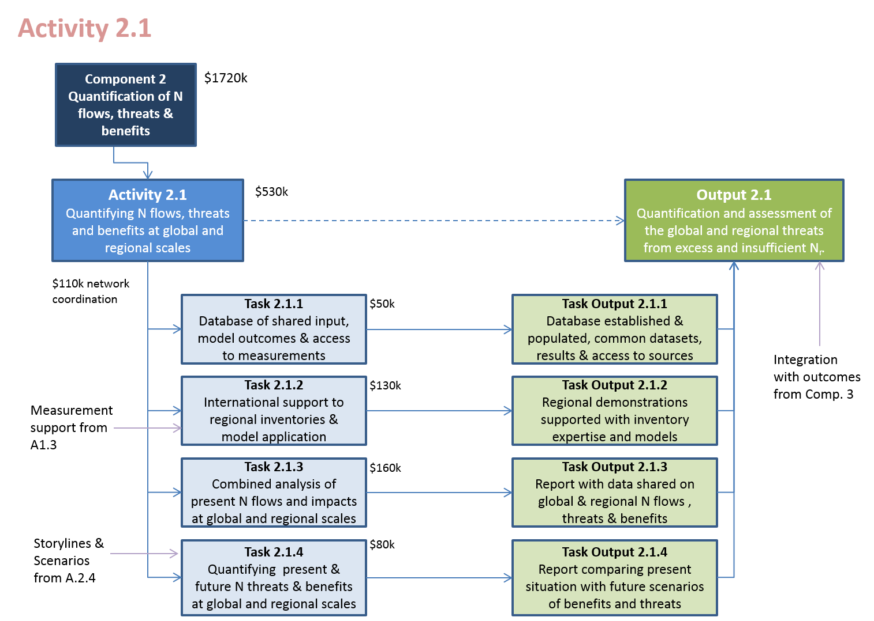
Figure A16.1: Summary of Tasks and Task Outputs needed to reach the overall Output in relation to quantifying nitrogen flows, threats and benefits (Activity 2.1; Output 2.1).
The outcomes of Activity 2.1, will provide key material for the consolidated global assessment of N flows, pathways and effects in Component 2.
A large number of INMS partners have proposed to contribute to this activity including: ALTERRA- (The Netherlands), CCST-INPE (Brazil), PIK (Denmark), FAO - AGA (International), JRC (EU), NERC (UK), ZJU (China), UGENT (Belgium), BFU (China), RRes (UK), LA UMR 5560 (France), ISSCAS (China), AU ENV (Denmark), SRI (Russia), MET Norway (Norway), EPA (USA), ECN (The Netherlands), INRA (France), IIASA (Austria), UoY (UK), ARI (Russia), PBL (The Netherlands), CAU (China), RIVM (The Netherlands), USGS for NANC (US), ILRI (Kenya), ‘New Energy’ (NGO, Ukraine), VU (The Netherlands), UED (UK), CARR (China), LVBC (Uganda), NIES (Japan), ASU (Lithuania), IFA (France).
IIASA (Austria) and ATB (Denmark), ALTERRA (The Netherlands), INRA (France) have also expressed interest to provide advice and review the work.

Task 2.1.1: Database of shared input, model outcomes & access to measurements
Task Output 2.1.1: Database established & populated, common datasets, results & access to sources
Task Co-leads: William Bealey (PCU, NERC, UK) and Jean Ometto (CCST-INPE, BR)
The key role of this task is to establish an accessible resource that allows coordinated access to datasets used in establishing INMS nitrogen inventories, inputs to models and sharing of key results. The main users of this information are therefore modellers of the nitrogen cycle facilitating improved cooperation and harmonization. By sharing key results datasets the outcomes will also be useful to users of the data including for comparison with monitoring and in support of the regional and global assessment proceses.
The first steps will be to review the different information sources available and analyse their distribution between partners and external bodies. This will consider issues of data accessibility (ease access, language, complexity of permissions etc) and establish a datasources profile that can inform the next steps. The key decision that will need to be taken is to agree the optimal balance between accessibility and centralization versus utilisation of existing distributed data sources. For this purpose, the distinction will be made between developing the database portal in ain way that most effectively provides ready access to different datasets, which are actually stored elsewhere, and datasets that are actually stored in the INMS database. Technically, this will be delivered through two distinct tools. The facilitation of data coordiantion and access will utilize the ENCORE data cluster system established by NERC under the ÉCLAIRE project. Where it is necessary to store key datasets (as in key model outcomes developed by the project) these will be archived on a dedicated INMS database to allow ready access to partners.
Several INMS partners have established expertise in this area, including NERC (UK), INBE (Brazil), PIK (Denmark), WUR (The Netherlands), PBL (The Netherlands), FAO, NIES (Japan), JRC (EU), IIASA and UNECE, which will be utilized to help develop the data strategy.

Task 2.1.2: International support to regional inventories & model application
Task Output 2.1.2: Regional demonstrations supported with inventory expertise and models
Task Co-leads: Howard (PCU, NERC) and Jean Ometto (CCST-INPE)
This task allows partners of Towards INMS to share expertise across the project, especially in the development of methods for inventory development and model application. The task can also be useful for sharing expertise on nitrogen measurement methods, especially in linking up between air, land and water parts of the nitrogen cycle. The main focus will be to support sharing of expertise between INMS partners leading in their respective fields within the INMS Regional Demonstrations (Component 3), with funds used to build partnerships.
The work will be developed in three stages. Firstly, the description of this task will be expanded and presented to the first General Assembly, with a propose set of priority criteria and topics areas for likely support. It will be up to the General Assembly to inform in case relative priorities should change. A starting position on criteria for prioritizing support is as follows: a) internationally leading sharing of expertise, b) a specific request for support from an INMS regional demonstation, c) first priority to N inventory and model development, but cases for sharing of measurement methods also to be considered.
Based on this confirmation, a call for short term misssions will be announced, and a short application form developed. It is anticipated that the application form should include:
- Name of the requesting INMS demo region, name and coordinates of the lead person requesting;
- Name of the INMS partner organization to undertake the mission;
- Name of the INMS partner expert to undertake the mission;
- Title of the mission;
- Short description of the purpose of the mission;
- Short description of the anticipated outcomes;
- Amount of grant requested;
- Short statement by receiving INMS demonstration region of its interest to host the mission;
- Applicant’s confirmation of agreement to deliver the mission report by a set date.
Requests for preparatory engagement from candidates for future INMS demonstration regions may also be considered. It is anticipated that the Task leaders will involve selected other INMS Partners and members of the Science and Policy Advisory Group (SPAG) to support the review process. It is anticipated that deadlines for applications may be set, with calls during Year 1, Year 2 and Year 3.

Task 2.1.3: Combined analysis of present N flows and impacts at global and regional scales
Task Output 2.1.3: Report with data shared on global & regional N flows , threats & benefits
Task Co-leads: Wim de Vries (WUR, NL) and Marine (tba)
This activity will focus on bringing together the different model components to deliver an overall analysis of nitrogen flows and impacts for present day conditions. It will build on the review of available models and model development activities of Component 1, encouring wide involvement from different groups.
For this purpose, agreement will be reached during the project inception phase on the best-suited base year, for which comprehensive datasets are available. It is ancipated that each of the main N flows, environmental compartments, and effects identified in Component 1 will be addressed using the agreed model cluster. It will be left open to the results of Activity 1.5, and subsequent confirmation with the Project Management Board (PMB) and General Assembly (GA), how the model cluster should look for this purpose. This is because a balancing act will be needed that addresses the necessary comprehensive approach, while recognizing that the GEF contribution to Towards INMS only provides a fraction of the necessary costs. Conversely, the substantial co-financing contributions may enable the combined analysis to include comparison of several models for parts of the nitrogen cycle, thereby increasing robustness of the outcomes.
A close link is envisaged between this activity and the preparation of the consolidated global assessment of nitrogen fluxes, pathways and impacts. It is therefore expected that as the overall synthesis effort under Activity 2.2 develops, it will feedback to identify priority recommendations for Task 2.1.3, as well as specific requests for ways to visualise the outcomes.
To support this process, the report for this task will provide material to stimulate feedback from the GA and the Stakeholder and Policy Advisory Group (SPAG), on how this may be best presented, e.g. as specific chapters in the overal global assessment of Activity 2.2.

Task 2.1.4: Quantifying present & future N threats & benefits at global and regional scales
Task Output 2.1.4: Report comparing present situation with future scenarios of benefits and threats
Task Co-leads: Wim de Vries (WUR, NL) and Marine (tba)
Based on the global scale modelling of N flows, threats and benefits for present conditions (Task 2.1.3) the approach will then be extended to address key global scenarios of possible future conditions. This will be informed by Activity 2.4 which will work to develop future nitrogen storylines and scenarios. While the focus of Activity 2.4 will be on envisioning different possible future outcomes and what might be needed to get there in broad terms considering the scale of the major drivers and the possible measures, including the possibilities for behavioural change by citizens, the focus of Task 2.1.4 will be to translate these into model runs that can best describe these scenarios.
Issues on data availability and model complexity will be used to inform the dialogue between these two activities, with input from the GA and SPAG being used to help clarify the prioritities for future scenarios (advice on choice of years, connection with other processes) and importance of different change options. Bearing in mind the balance of these issues (resources, versus ambition, versus advice on priorities) agreement will be reached on which future scenarios could be carried through to full application by the INMS model cluster.
As with the previous task, the report from Task 2.1.4 will provide the opportunity to encourage feedback from the PMB, GA and SPAG, with advice on issues to consider when summarizing the work for the global assessment of Activity 2.2.

Activity 2.2: Preparation of global assessment of N fluxes, pathways and impacts assimilating lessons from the regional demonstrations
Output 2.2 Detailed overview of regional/local N flux and consolidation into a global assessment of N fluxes, pathways, effects and benefits of improved N management
Activity Co-Leads: INI (Sutton and Howard, PCU, NERC).
The different steps in this activity are summarized visually in Figure A16.2. These include preparing the scope and structure of the consolidated assessment, commissioning lead author teams and preparing chapter drafts of the consolidated overview, peer-review of the chapters and revision, preparation of summary documentation supported by a specific review workshop, and finally publishing and disseminating the consolidated assessment.
This activity is an important one for the INMS process as it provides a key vehicle to present and synthesize the main achievements of Towards INMS to a global audience. The synthesis process will also allow the key messages to be refined, which will provide the underpinning material to support INMS communication and awareness raising in Component 4. Experience of the Project Coordination Unit (PCU) with other such processes, including the European Nitrogen Assessment and the Global Overview on Nutrient Management – ‘Our Nutrient World’, has shown that such consolidated syntheses have a huge power to communicate on the global stage. In this way, media engagement can stimulate public awareness and policy initiatives, which in turn feed back to develop future opportunities in international mobilization faciliating changes in practice on the ground.
The very process of preparing such a synthesis is also expected to stimulate new ideas in the targeted research itself. For example, the process of identifying key parts of the global report and its potential chapters typically results in other topics/issues being identified where there is currently insufficient attention. This process may lead to a proposal to amend the INMS work plan, so as to address these new priorities. For this reason, and also given the time taken to prepare such a global synthesis, it is planned that the process will kick off at the start of Towards INMS and run through its full duration.
While this activity is led directly by the PCU, it is expected that it will draw on all the Components and Activities. Specifically, it is planned that Component Leaders will play a key role together in coordinating this process, drawing inputs from other INMS partners. The PCU will make a first proposal as to overall structure to the Component Leaders, Implementing Agency and Executing Agency (together the PMB) for revision and presentation to the SPAG and GA. This will then support a process of mapping of outputs of INMS Activties and Tasks into the global synthesis and, from this, the nomination of lead and contributing authors.
In this way, it is anticipated that a first outline concept of the consolidated global assessment will be produced during Year 1 of Towards INMS for review and adoption by the GA. This will then allow a more detailed mapping of chapter responsibilities in Year 2. The actual drafting would be conducted in Year 3, with final outcomes included during Year 4 (especially where these are not planned to be ready earlier). Finally, peer review and finalization of summarizes and production will be made during Year 4. Subject to confirmation of the proposal on timing and strategy by the Implementing Agency (UNEP) and the GA, it is proposed to launch the product as part of the final INMS conference at the end of Year 4.
This Activity will draw on contributions from across the INMS partnership, including all four components. Component and Activity leaders will play a key role in supporting the process, with specific chapters anticipated on the different INMS Regional Demonstrations. In addition to core writing by science experts, contributions and advice from SPAG members will be encouraged.

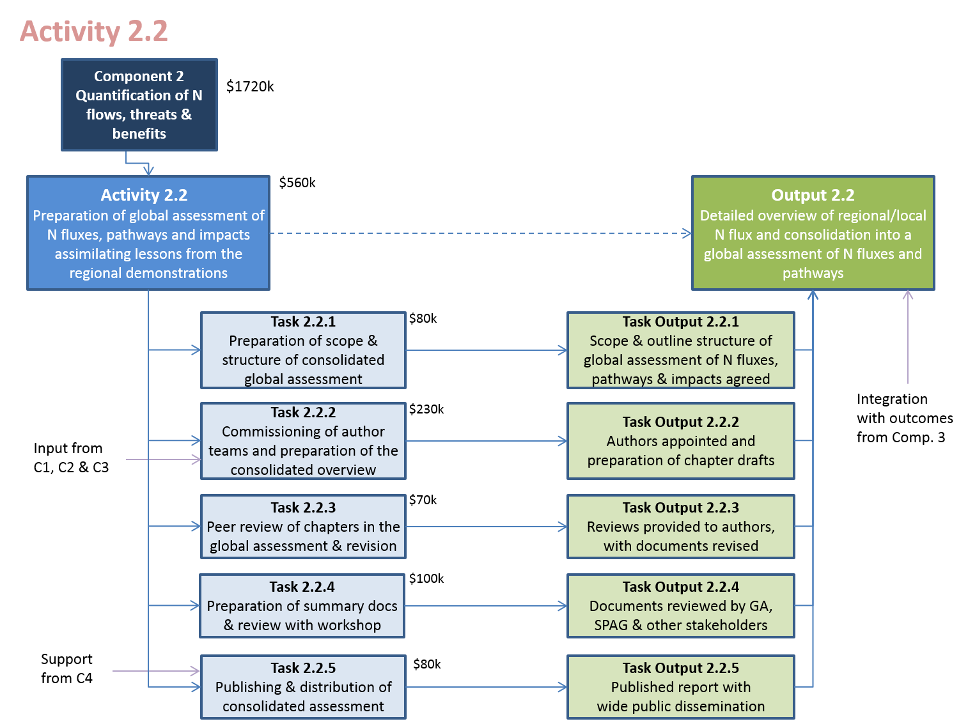
Figure A16.2: Summary of Tasks and Task Outputs needed to reach the overall Output in relation to preparation of global assessment of N fluxes, pathways and impacts (Activity 2.2; Output 2.2).

A number of INMS partners have proposed specifically to contribute to this activity, including: NERC (UK), ALTERRA (The Netherlands), ILRI (Kenya), UGENT (Belgium), IIASA (Austria), FAO AGA (International), INRA (France), RRes (UK), PIK (Germany), PBL (The Netherlands), JRC (EC), ECN (The Netherlands) and VU (The Netherlands).

Task 2.2.1: Preparation of scope & structure of consolidated global assessment
Task Output 2.2.1: Scope & outline structure of global assessment of N fluxes, pathways & impacts agreed.
Task Co-Leads: INI (Sutton and Howard, PCU, NERC).
During year 1 of the project, a first outline concept of the global assessment will be prepared by the INMS Project Coordination Unit, which will aim to achieve the following elements: a) Addresses the core challenge of why a cross-cutting approach to the nitrogen cycle is relevant, clearly summarizes the baseline and explains the overarching framing of the sections that follow, b) addresses the nature of the key sources of nitrogen and their drivers, c) addresses the pathways of nitrogen and its interconversion between different N forms at different temporal and spatial scales and how this has relevance for consequences, d) addresses the major impacts of human alteration of the nitrogen cycle, including the multiple benefits and threats, e) addresses current and emerging options for improved management of the nitrogen cycle, including examination of future storylines and scenarios, and possible vehicles for change (through communication, policy, practice etc), f) illustrates these challenges and possible solutions, including success stories, by reference to a series of major case studies for different world regions, drawing on the INMS regional demonstrations, g) synthesizes the key drivers, needs, barriers-to-change and options for overcoming them. These elements might contribute major parts of the final product, which would then be used to prepare technical and executive summaries for wider distribution.
The draft scope and outline will be reviewed initially by the PMB, for sharing with the GA and SPAG as a basis for providing a revised version to be agreed by the GA. At the same time, material will be provided summarizing the process for the next steps to be agreed by the GA.
It is expected that there will be a close link between Component Leaders and editors of the consolidated global assessment. In the process of undertaking this activity, it is anticipated that there may be important feedback to other activities, especially A2.1, A2.3 and A2.4. For example, this may include identification of critical factors, caveats and emerging trends.

Task 2.2.2: Commissioning of author teams and preparation of the consolidated overview
Task Output 2.2.2: Authors appointed and preparation of chapter drafts
Task Co-Leads: INI (Sutton and Howard, PCU, NERC).
Based on agreement of the overall approach and process by the GA, this Task will focus on preparing the coordination team for the consolidated overview, including identification of lead and contributing authors to different chapters. The PCU will particularly draw on advice and inputs of the Component and Activity leaders and provide a means for all INMS partners to offer their input. Proposals will be tested with support from the SPAG, as a basis for agreement by the GA. This will then allow the PCU to commission author teams, setting out a) the scope and objectives of each commissioned section, b) the necessary elements to be consdered, including problematique and kinds of information to be included, c) issues of common style and format, d) timetable and review process. As far as possible, authors will be requested to indicate degree of confidence/uncertainty in their conclusions and key messages.
It is expected that the actual process of preparing chapters and sections of the consolidated global assessment will take place as part of the work of the different Activities and Tasks of INMS, which is also serving to focus on ensuring that key higher-level outcomes are achieved.

Task 2.2.3: Peer review of chapters in the global assessment & revision
Task Output 2.2.3: Reviews provided to authors, with documents revised
Task Co-Leads: INI (Sutton and Howard, PCU, NERC).
This task will manage the peer review process of the draft chapters, ensuring that the material meets a leading international scientific standard. Reviewers may be selected from within as well as outside of INMS and depending on the nature of a chapter, may include both scientific review and expert review from policy and practice stakeholders. During Task 2.2.1, the process to invite authors will also invite offers for chapter reviewers. The list of possible reviewers will be extended to include other international experts from beyond the INMS community to ensure full independence of the review and a high standard. Peer reviewed chapters will be returned by the PCU to lead authors for revision under an agreed timescale. Authors will be required to amend chapter drafts and provide a summary of the changes they have made, so that the editors can make a decision whether further review and revision is necessary. Each chapter will include a short summary of key messages, which will be checked for consistency with the evidence provided in the chapter. This will allow authors to prepare revised versions for submission to the PCU.

Task 2.2.4: Preparation of summary documents & review with workshop
Task Output 2.2.4: Documents reviewed by GA, SPAG & other stakeholders
Task Co-Leads: INI (Sutton and Howard, PCU, NERC).
The finalized chapters will be used to prepare summary documents of the overall consolidated assessment, with input from the GA, SPAG and other stakeholders. It is anticipated to include two forms of summary, one focused more at policy makers, and one focused more at a technical and scientific audience. However, this proposal will be reviewed before a final decision is taken. The draft summary(s) will be prepared by the PCU with the support of other editors and experts. The final summary will then be opened for review by the GA, SPAG and stakeholders, which will be used to finalize the document.
This process will also need to manage the possibility of divergent views and stakeholder positions, especially given that the SPAG includes stakeholders with different views. It may therefore not be possible to produce a consensus document that satisfies every stakeholder. In this regard, it shall be declared that the consolidated assessment expresses the opinions of the experts listed as authors, according to the authorship of each chapter / summary (not their organisations), while the chapters / summary will seek to capture the esssence of different arguments where as far as this is necessary to make the outcomes clear.

Task 2.2.5: Publishing & distribution of consolidated assessment
Task Output 2.2.5: Published report with wide public dissemination
Task Co-Leads: INI (Sutton and Howard, PCU, NERC).
Negotiations will be entered into with leading publisher(s) to maximize the public dissemination opportunity of the global consolidated assessment. Outline discussions have already been had with Cambridge University Press, who have indicated their enthusiasm to publish the product on behalf of INMS, INI, UNEP and GEF. However, the merits of other altenatives will need to be considered before a final decision is taken. The PCU envisages the consultation with the PMB, GA and SPAG under Task 2.2.1 will also include feedback on the choice of publisher to maximize global impact.
This task will then cover the process of publishing the consolidated assessment, including submission of final texts and artwork, layout, preparation of proofs, checking with authors, finalisation and distribution itself. This will provide material for action in Component 4 to develop further communication and dissemination approaches, including with press and other media.
As part of this task, ongoing discussions will continue on the relationship of this INMS/INI/UNEP process to other international assessment processes, in particular IBPES and IPCC. There may be advantages to link these processes, but the timing and arguments need to be further evaluated.

Activity 2.3: Integrating methods, measures & good practices to address issues of excess & insufficient reactive nitrogen
Output 2.3: Consolidation of methods and good practices to address issues of excess and insufficient reactive nitrogen
Activity Co-Leads: TFRN / EU Nitrogen Expert Panel (Oenema, WUR) and TBA
At present guidance for good management of nitrogen tends to be fragmented between different forms of nitrogen and different issues. In order to fully exploit the synergies that operate through the nitrogen cycle, and to avoid trade-offs that can also result from the biogeochemical linkages, there is a pressing need to develop consolidated guidance on methods and good practices. Such methods and good practices can be relevant in both areas of excess N (reducing pollution threats) and in areas of insufficient N (making use of limited available resources). In fact, both issues apply in both cases: N losses still contribute to pollution even in areas of insufficient agricultural N, while the improving resource use can offer substantial financial benefits in areas of excess N.
This Activity complements the global synthesis of Activity 2.2 as well as contributing to it. Its purpose is more technical, focusing on reviewing and integrating detailed descriptions of management guidance for parts of the nitrogen cycle into a comprehensive whole. The starting point is to gather different existing published sources on good practice guidance, also drawing on the Tool developed as part of the UNEP/GEF Global Nutrient Cycles Project, which is a part of the Global Partnership on Nutrient Management. Such documents have been prepared by many bodies and range from the summary guidance of UNEP (2013) in “Drawing down N₂O” to detailed descriptions of water pollution by national bodies such as US EPA and the European Union, to comprehensive listing of the options for reducing ammonia emissions in the UNECE Ammonia Guidance Document. The challenge is to bring these together, while reviewing emerging technologies and approaches, to prepare more synthetic guidance that highlights the win-wins-wins for food production, soil, water and air quality, climate, biodiversity, and energy.
Particular attention needs to be given to the better management of nitrogen in agriculture (fertilizer and manures including issues linked to biological nitrogen fixation where relevant). However, the activity needs to consider all possible sources of N where better management practices can be developed to reduce adverse effects and offer improved access to the benefits of nitrogen. Therefore it is anticipated that the activity and prepared guidance will also include sections on reducing (and especially recapturing and recycling) NO_{x} emissions, as well as recycling other N resources such as from solid waste and waste water. An overall philosophy to develop better nitrogen recycling approaches rather than denitrification approaches will be explored, especially how this can contribute to Green Economy and Circular Economy developments.
The output will consist of a synthetic guidance document for wide dissemination to countries, international organisations, business and advisory services. In addition, it is expected that the key messages will be incorporated as a specific chapter or chapters in the consolidated global assessment (Activity 2.2). Thirdly, the document will be useful as a key resource to support wider dissemination in Component 4, such as through the identification of a “nitrogen top-ten”: identifying the top ten actions for better nitrogen management, which can be useful for countries, business and civil society.
INMS partners who have proposed to contribute to this activity include: ALTERRA with WU (The Netherlands) , NERC (UK), ENEA (Italy), University of Aarhus (Denmark), ISA (PT), BBRI (India), CAU (China), UNECE, RRes, IARI (India), WRI (US), ISSCAC (China), ECN (The Netherlands), INRA (France), UoY (UK), CIMMYT (Mexico), ADEME (France), ARI (Russia), PBL (The Netherlands), North American Centre of INI (represented by USGS, including collaborative stakeholder programme on Agriculture Committee of Rocky Mountain National Park), ILRI (Kenya), FAO AGA (International), VU (The Netherlands), ATB (Denmark), JRC (EU), Fertilizers Europe (Europe), ENEA (Italy).
The following are anticipated to contribute advice and as reviewers: WUR LR (The Netherlands), PCH (Spain), DETJTR (Australia), AgResearch Ltd (New Zealand). As this activity develops the core teams will work to include other areas of expertise in this activity so as to widen its relevance and eventual impact. This will also allow the activity to profile new innovations in its activity.

Task 2.3.1: Preparation of documents on state of the art for best nitrogen management practices
Task Output 2.3.1: Background documents produced & available for workshop input
Task Co-Leads: Oenema (WUR, NL) and tba
The first task of this activity is to gather material that is already available on good management of different parts of the nitrogen cycle for different impacts. The information to be gathered should cover the following sectors and the following issues.
With regard to sectors, particular attention will be given to collecting management guidance on agriculture (including cropping systems, manure management and livestock management). In addition, attention will also be given to management in later parts of the food chain (although subject to agreement, this is not expected to include households and citizens choices which are addressed in Activity 1.6). Attention will also be given to other sectors including current guidance for reducing NOx emissions and the potential to develop NO_{x} recycling opportunities, as well as recycling of nitrogen in solid wastes and waste water streams.
With regard to impacts, available guidance will be brought together as this links to all major impacts of N losses including effects on water quality (freshwater and marine), air pollution, greenhouse gases and economic effectiveness for sectors. For the latter, this implies the inclusion of measures that not only reduce reactive nitrogen losses, but also losses of denitrification to N₂, given the substantial product value (i.e. fertilizer and other value) of N losses.
It should be emphasized that it is not the role of this task to address these different impacts and issues, which are being addressed elsewhere in Towards INMS. Rather, this task needs to take account of each of these issues in developing joined up guidance for good nitrogen management.
This task will simultaneously work to further build the international Community of Practice in good nitrogen management methods, bringing together experts from different areas of expertise. It will be supported in this regard by dissemination activities in Component 4.
The task will lead to the preparation of a group of background documents which can stimulate discussion on these issues. In particular, it will stimulate a first concept of how a future joined up guidance document for nitrogen management should look, and to which policy frameworks it would be linked (e.g. UNEP, UNECE, CBD, GPA, FAO etc).

Task 2.3.2: Workshop to link methods & good practices for N effects (food, water, air, climate etc)
Task Output 2.3.2: Basis for developing guidance linking N forms & issues, high-lighting most promising options
Task Co-Leads: Oenema (WUR, NL) and TBA
The workshop will bring together experts in a wide range of disciplines relevant to reducing nitrogen losses and promoting good practices to minimize the adverse effects of nitrogen and to maximize the co-benefits, for economy, environment, food and health etc. The discussion will be informed by presentation of the background documents, and a proposal made for how the joined up guidance should look.
The proposal, including the vision, scope and outline structure will be provided to the PMB and SPAG for their comments, and then submitted to the GA for amendment and agreement on the approach.
Note that it may be possible to structure this as two workshop (a, wider scoping and b, more detailed review) which will also facilitate close engatgement with SPAG and GA. Whether it is possible to do this in two steps will depend on the potential for synergies with other workshops (e.g. back-to-back appraoch) and the potential for drawing in additional cash co-financing.
In parallel, it is expected that the concept document be shared in the relevant policy domains where it can contribute simultaneously, for their feedback and to foster their engagement in the process. This will include regional conventions/programmes linked to the INMS demonstrations, e.g. UNECE (LRTAP and Water Conventions; European Union; Black Sea Commission, Danube River Basin Commission; South Asia Cooperative Environment Programme (SACEP), PEMSEA, LVBC; La Plata River Basin Commission etc.), as well as global processes including UNEP, CBD, GPA, GPNM, FAO, IPCC, Vienna Convention (Montreal Protocol), WHO and WMO.
In this way, this process will foster engagement in the developing concept of a ‘nitrogen policy arena’ in cooperation with Component 4.

Task 2.3.3: Publishing of revised papers and preparation of synthetic guidance document
Task Output 2.3.3: Workshop report, with guidance document synthesized for wide review
Task Co-Leads: Oenema (WUR, NL) and TBA
Based on the workshop report and wider stakeholder feedback the background documents will be used as a basis to prepare sections/chapters to a draft guidance document. This will provide a first version of the draft guidance document on joined-up nitrogen management, which can then be provided back to stakeholders (as listed above) for their review.

Task 2.3.4: Peer and Stakeholder review of Synthetic N guidance document
Task Output 2.3.4: Text of consolidated guidance document finalized
Task Co-Leads: Oenema (WUR, NL) and TBA
It is anticipated that the process of review of the guidance document may need to be conducted in an iterative fashion. This is because the timing of different stakeholder feedback may be hard to constrain into a narrow period of time (e.g. if other policy processes are operating on dfferent process timescales). Nevertheless, a review period will be set in which partners of Towards INMS, stakeholders, and wider policy processes (listed above) will be invited to send their comments, so as to conduct the revision in a timely fashion. It will be noted where other policy processes are anticipated to provide planned further recommendations and inputs at a later stage, specifying which timing is anticipated and which process this links to. This will be important to set the final document from this round (First edition of the UNEP/INMS Nitrogen Guidance) in context and anticipate in advance what future revisions will be necessary under future projects (after ‘Towards INMS’).
Any issues on difference of strategy or position will be referred to the PMB and SPAG for their advice, with the final document presented to the INMS GA for its adoption.

Task 2.3.5: Publishing of synthesis document & updating of practice database
Task Output 2.3.5: Consolidated methods/practice report & database published
Task Co-Leads: Oenema (WUR, NL) and TBA
It is anticipated to publish the results of the guidance in two forms. Firstly, the main synthesis document will be pubished as a key INMS output for wider dissemination. This will be supported with a publication budget managed under Activity 4.5. Secondly, the material will be incorporated into the INMS database. It is anticipated that this database will take as a starting point the Tool Box of measures developed under the GEF/UNEP GNC project. However, it may also be relevant to reap the benefits of other similar databases that are identified in the process of conducting Activity 2.3, especially in developing links though the emerging ‘nitrogen policy arena’ with different policy processes as users of the information.
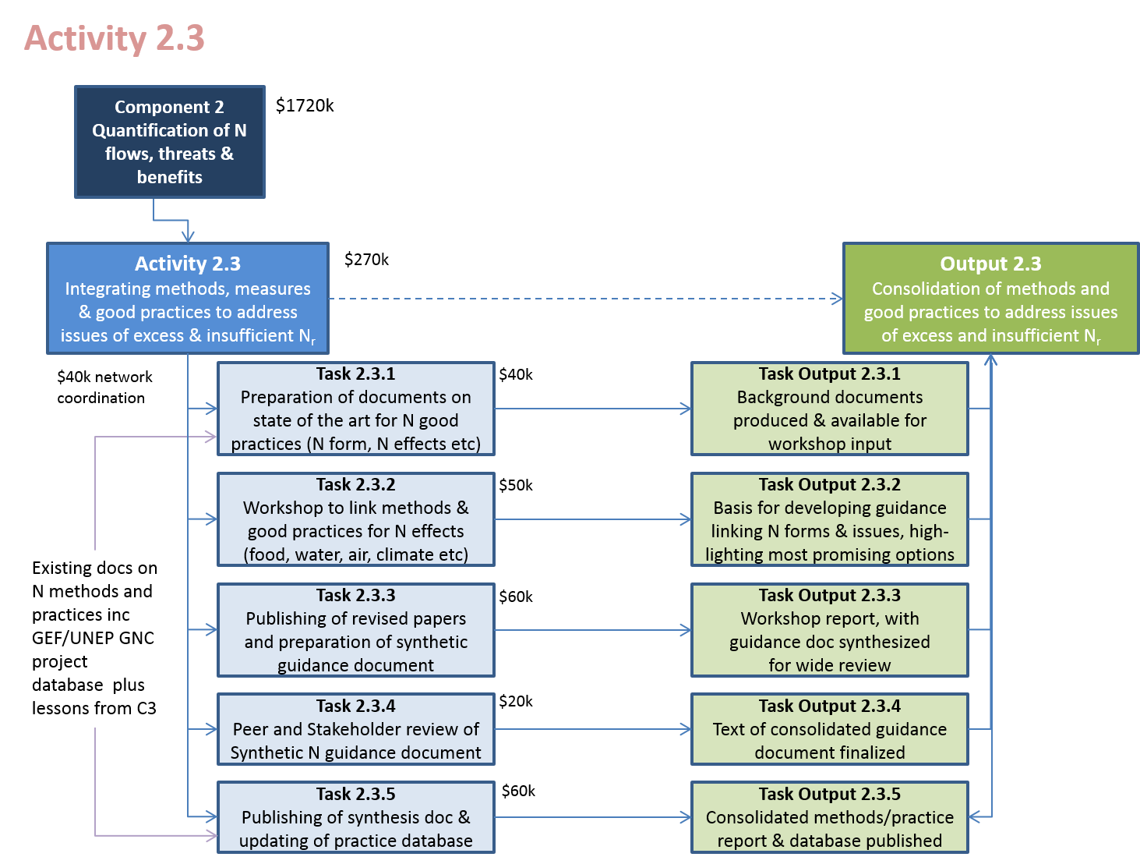
Figure A16.3: Summary of Tasks and Task Outputs needed to reach the overall Output in relation to integrating methods, measures and good practices to address issues of excess and insufficient reactive nitrogen (Activity 2.3; Output 2.3).

Activity 2.4: Exploration of future N storylines & scenarios with management/ mitigation options & cost-benefit analysis
Output 2.4: Definition of programmes & policy options for improved reactive nitrogen management at local/regional/global levels, supported by cost-benefit analysis to underpin options for the Green Economy
Activity Co-Leads: INI Europe / TFRN (Winiwarter, IIASA) and INI North America / SDSN (Kanter, New York University)
The purpose of this activity is to examine how the global nitrogen cycle may alter in the future and what the consequences of this future change would be. For this purpose, broad storylines will be considered to frame possible futures, as well as specific scenarios of ‘what if’ considered.
The starting point will be a review of existing nitrogen policies for different regions and countries, examining what policies they have in place and how these link to the nitrogen cycle, the extent to which synergies across the nitrogen cycle are addressed, and the extent of gaps. This first task will serve a dual role to inform the storyline and scenario development, but also to inform the interaction with international policy processes in Component 4.
In considering possible future storylines, attention will be given to current thinking on storylines in other domains, including those from food production, climate, air, biodiversity and water communities. For example, the Special Report on Emission Scenarios, earlier used four main storylines (A1, B1, A2, B2) to characterize different possible futures, which subsequently informed the storylines of the Millenium Ecosystem Assessment. In turn, later work on climate has considered Representative Concentration Pathways (RCP, linked to a certain degree of radiative forcing) and Shared Socioeconomic Pathways (SSP). These examples will need to be considered in relation to scenario approaches used by the transboundary water and air pollution communities and specifically their impact on nitrogen compounds,,. Similarly, an emerging narrative is that of ‘planetary boundaries’,, and it will be examined to what extent this framing can be useful for analyzing the challenges of too much and too little nitrogen.
In considering future scenarios, the link will be made with what are often called ‘business as usual’ scenarios, considering how this relates to particular storyline development. This may illustrate, what would happen if no active changes are made to the way nitrogen is managed in the world, i.e. the consequences of no action. This will be contrasted with what might be achieved by different actions, including through technical measures in different sectors and through societal changes. This first of these may include water and air pollution mitigation technologies (emission reduction focus) as well as strategies to improve nitrogen use efficiency (green and circular economy focus), as these are relevant in e.g. arable agriculture, livestock production, combustion processes and waste water treatment. The second of these may include the effect of different future human populations, consumption choices related to the mix of food and energy types, and human choices on domestic waste. While it will necessarily be impossible to address every interaction in detail, a key part of the work will be to identify a) which measures / actions offer the major opportunities for change (reducing adverse effects of N and improving the retention of N benefits) and b) how these may be be grouped into distinct classes of action, c) where there is potential for synergy across the nitrogen cycle (in cooperation with Activity 2.3) and d) what are the priority measures that need to be incorporated into global and regional models describing scenarios of the future nitrogen cycle.
It is anticipated that particular attention will be given to key future years, such as 2050 and 2100. However, the decision on how much to focus on these years or other years, will need to be made based on the review of existing available scenarios from existing processes as these link to different aspects of the problem (e.g. climate, water, air, biodiversity) and the opportunity (e.g. food and energy supply). It is important to emphasise that these scenarios will need to consder both the benefits of nitrogen and the threats, and both areas with excess and insufficient reactive nitrogen.
INMS partners who have proposed to contribute to this activity include: IIASA, New York University (US), PIK (Denmark), PBL (The Netherlands), OECD, FAO, UNEP, CBD, UNECE, ZJU (China), WRI (US), CARR (China), ECN (The Netherlands), UoY (UK), ADEME (France), AU ENV (Denmark), ISA (PT), VU (The Netherlands), NERC (UK), JRC (EU).
The following propose to contribute advice and to act as reviewers: INRA (France), PCH (Spain), RIVM (The Netherlands), IFA.

Task 2.4.1: Review of existing N policies for different countries & regions
Task Output 2.4.1: Report with database as input to workshop on N policies, storylines & scenarios
Task Co-Leads: Bonnis (OECD), Kanter (New York Univesity)
This task will serve to bring together information on policies linked to nitrogen in different regions and globally. For this purpose the work will connect directly with the policy initiatives of countries, engaging closely with the programme in this area of OECD, but also extending this to other key INMS countries beyond OECD. To do this, the policy review approach questionnaire of OECD will be reviewed at the start of the project, and modified as necessary considering other regional/national needs. This will then be shared with partners in the INMS Regional demonstrations to support their engagement with national governments and regional environmental agreements. The collected information will be used firstly to create a simple database, allowing others subsequently to add information, which will be developed in partnership with the PCU. Secondly and more importantly the information will be synthesized to provide a better understanding of the gaps in policies, extent of synergies and trade-offs, and to explore possible routes by which a stronger gravity for action can be developed by joining up across the nitrogen cycle.
The first review will feed as a background document to the INMS workshop on storylines and scenarios, which will then inform the next steps on priority for this work. Depending on the acquisition of additional external resources this work may be extended to consider how the planetary boundary approach could be more closely linked into future policy development for nitrogen.
Depending on the availability of additional resources, this task may also go further in analysing the experience of different policy instruments linked to nitrogen. The starting point will be information collected from the country case studies, which can then be used to synthesize information on the opportunities, strengths, limitations, etc, of different policy instruments.

Task 2.4.2: Review of existing storylines and scenarios relevant for N
Task Output 2.4.2: Document as input to workshop on N policies & scenarios
Task Co-Leads: Winiwarter (IIASA) and Kanter (New York University)
This task will provide the basis to prepare for a workshop that brings together different views on storylines and scenarios for nitrogen in relation to its multiple benefits (food, fibre, energy etc) and threats (water, air, greenhouse balance, ecosystems, soils etc), linking environment and health issues. The background document will seek to bring together the current status of different existing approaches to nitrogen scenario development on both regional and global scales. This dual focus is important given the multi-scale relevance of nitrogen, which links local and regional issues (e.g. water quality, air quality, biodiversity) with global issues (climate, trade, barriers, economy etc).
In preparing the background document, an initial compilation of existing scenario approaches and storylines will be shared with the contributors to Activity 2.4 in order to broaden the scope, integrate different aspects of individual focal areas and stakeholder groups and interests. At the same time, this allows dissemination of status information within the community in an early project phase. Specific contributors may be invited to provide elements of the background document once its scope has been defined as part of the initial compilation.

Task 2.4.3: Workshop on N storylines and scenarios for shared use across the project
Task Output 2.4.3: Published strategy for N storylines and scenarios
Task Co-Leads: Winiwarter (IIASA) and Kanter (New York Univesity)
The focus on this workshop will be to bring together those with expertise and current involvement in developing and applying future storylines and scenarios for nitrogen, while coming from many different perspectives. It is anticipated to include the latest thinking on scenarios linking nitrogen to climate (with links to current IPCC scenarios development, e.g. SRES, SSP and future), to air quality (e.g. LRTAP, US, EU, China, India scenarios), to water quality (scenarios from regional seas / waters conventions and programmes, including Black Sea, Baltic Sea (HELCOM), Mediterranean, East China Sea (PEMSEA), UNECE Transboundary Waters Convention, LVBC, La Plata River Basin Commission. Subject to further discussion and external resources it may also be possible involve also the Gulf of Mexico (Cartagena Convention).
In bringing the science and policy communities together for nitrogen, a vision will be developed for how synergies can be identified in future scenario development. The draft document will be reviewed by the Project Management Board (PMB) and the Stakeholder and Policy Advisory Group (SPAG) for adoption by the General Assembly (GA), leading to the publishing of an INMS nitrogen scenarios strategy. This strategy will include among points, clear recommendations on the issues that need to be addressed in nitrogen strategies, the benefits from considering different nitrogen-related issues together in future strategies, and list of priorities for capability that needs to be included in models to address the most important future options (e.g. types of management and mitigation action in different sectors, opportunities related to food and energy choices etc.)
Drawing especially on Activities 1.4 (cost benefit analysis), 1.6 (barriers to change) and 2.3 (technical options and measures), this Task will work with Activity 1.5 and 2.1 to generate the agreed scenarios that will be used in the simulations of the INMS modelling cluster.

Task 2.4.4: Synthesis of future programmes and policy options supported by scenario development and cost benefit analysis.
Task Output 2.4.4: Report on nitrogen policy options and their possible contribution to the Green Economy.
Task Co-Leads: Winiwarter (IIASA) and Kanter (New York Univesity)
As the activity develops in relation to future nitrogen scenarios across INMS, several future developments and opportunities will be expected. These can also be linked to the emerging development of the policy landscape, especially in the context of the ‘nitrogen policy arena’. In this regard this Task will link closely with Activity 4.3 on international processes in order to inform the policy arena and to feedback to the development of supporting concepts and approaches.
This work will also link to progress in the Sustainable Development Goals (both development and implementation, as that process progresses), and to the development of processes linked to planetary boundaries, exploring how the planetary boundary concept can be refined for nitrogen and conversely how the nitrogen case could support the planetary boundaries approach.
Subject to additional external resources being obtained, a target setting approach to linking nitrogen scenarios to planetary boundary options may also be developed.
The output of this task will be a report on policy options, their relationship to future global economy and wellbeing, linking, for example, to the current state of concepts such as the Green Economy, Green Growth and the Circular Economy.
As an INMS technical document focused on policy analysis, it its not anticipated to be the role of this Task and its report to advocate specific solutions. Rather the focus is expected to be on understanding the consequences of different options, their implications and risks, as well as highlighting key opportunities. In this way, it is anticipated that the report will play an important role to stimulate discussion within the nitrogen policy arena (including countries, international conventions and programmes, business, civil society etc).

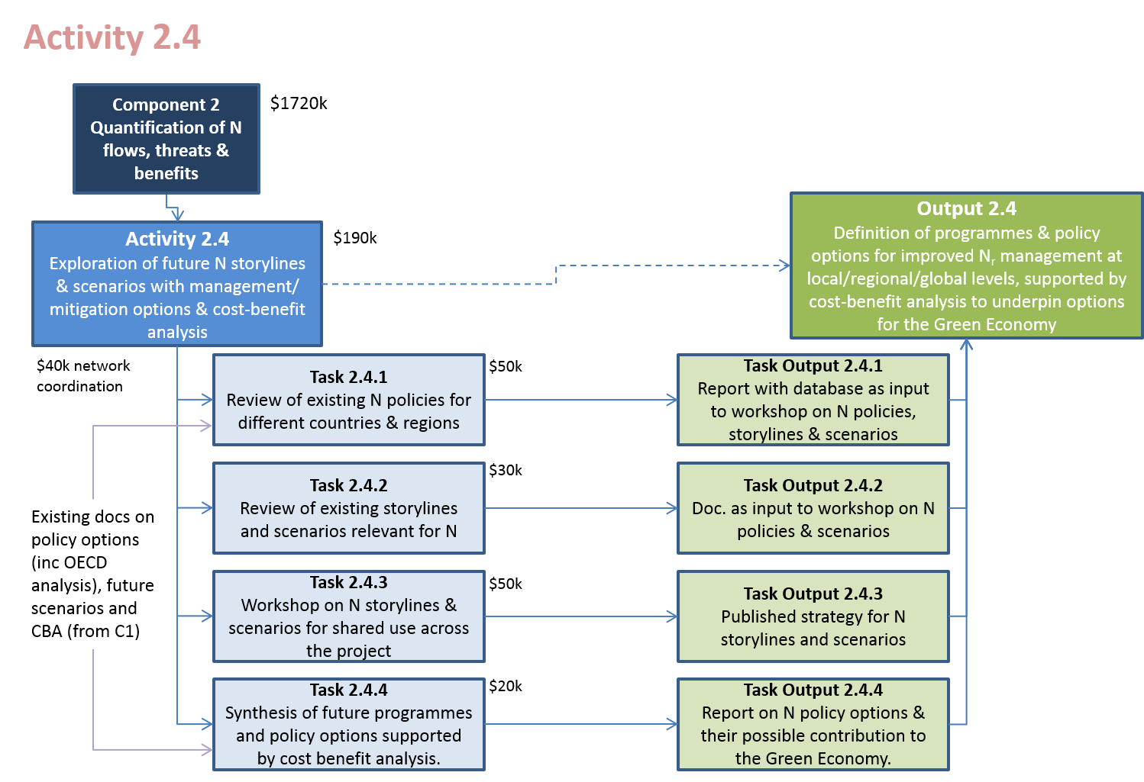
Figure A16.4: Summary of Tasks and Task Outputs needed to reach the overall Output in relation to exploration of future N storylines & scenarios with management/ mitigation options & cost-benefit analysis (Activity 2.4; Output 2.4).

Activity 2.5: Collation & synthesis of knowledge, experience & measures adopted by GEF and others on excess & insufficient reactive nitrogen
Output 2.5: Compendium summarizing the state of knowledge, experience and measures adopted by GEF (and others) gained from addressing the issues of excess and insufficient reactive nitrogen
Activity Co-Leads: GPNM (Walker, WRI, US and Bleeker, ECN, NL)
The aim of this task is to produce a compendium summarizing what has been achieved by GEF and others, including OECD, UNECE and other international and national programmes, through previous and ongoing interventions related to the nitrogen cycle. The focus here is not just on scientific underpinning and on policy development, but even more on achieving changes in practice, giving examples of success stories related to better nitrogen management that can be shared with a wider audience. This may include examples of demonstrating a new technological approach to improve nitrogen use efficiency or reduce N losses, the sharing of improved monitoring and awareness schemes (e.g. farm N budgeting, ecosystem health record card approach), demonstration of approaches to overcome barriers to change, and demonsttration of success stories that show improved environmental quality.
While the starting point will be a review of GEF actions, the analysis will also be widened by engagement through the INMS network, including the Regional Demonstration Partners to identify other examples for inclusion in the review. These will include examples of bi-lateral country pairing, where these can be identified and given more visibility through the INMS review and database.
This synthesis should not, however, only be an uncritical search for success stories. As the information is brought together, it is expected that common messages may emerge where barriers to change are not solved, where methods adopted are not sufficiently integrative (e.g. with risks of nitrogen pollution swapping) or where mistakes have been made that the INMS community needs to learn from. The aim here will be learn from this synthesis to see how stronger nitrogen approachces can be developed in future.
INMS partners who have proposed to contribute to this activity include: WRI (US), ECN (The Netherlands), OECD, Indian Nitrogen Group (India), ISA (Portugal), VU (The Netherlands), ATB (Denmark), NERC (UK).
The following are expected to offer advice and to act as reviewers: INRA (France), UBA (Germany), ADEME (France), PBL (The Netherlands), FAO AGA, LVBC (Uganda), UNECE, The Commission on the Protection of the Black Sea (BSC PS), UNEP.

Task 2.5.1: Review of N measures adopted by GEF and incorporation into database
Task Output 2.5.1: Database and summary document on GEF N measures
Task Co-Leads: Walker (WRI, US) and Bleeker (ECN, NL)
The first task will focus on bringing together information from past GEF projects as far as these link to the nitrogen cycle, but which can also be used for collection of information from other sources (e.g. GPA, OECD, CBD, LRTAP, GPA, CDM, Montreal Protocol and other regional conventions and programmes).
At the outset a form will be designed to gather information on measures that can form the basis for information collected in the database. The format will be designed by the Activity leaders in cooperation with the Component leaders and PCU. This will then be reviewed by the PMB and SPAG to get their feedback as a basis for finalizing the data collection structure. Although it is not proposed to present this database structure for a decision by the GA, all partners (i.e. GA members) will be invited to supply comments where they have an interest, at the same time as flagging up examples that they suggest be included in the database.
The starting work of Task 2.5.1 will allow the Activity Leaders to ensure that the database structure is finalized, and the database itself constructed. The data gathering process will then commence, simultaneously contributing to populate the database and to provide material for the compendium. In cooperation with the PCU it is anticipated to make this database available on the INMS website. A summary document on measures adopted by GEF will provide an output to share with the PMB, SPAG and GA.

Task 2.5.2: Review of N measures adopted by others including from INMS demonstration regions and inclusion into database
Task Output 2.5.2: Database and summary document on N measures adopted by others
This task allows for the continuation of Task 2.5.1, extending it beyond GEF actions to engage with other sources of information, including from other regional programmes, bilateral initiatives and INMS regional demonstrations. The database and report will be updated accordingly.

Task 2.5.3: Preparation of compendium of knowledge on N measures
Task Output 2.5.3: Synthesis supported by database on N measures as contributions to global assessment (A2.2)
Task Co-Leads: Walker (WRI, US) and Bleeker (ECN, NL)
Once the main information gathering phase is completed, it is anticipated that the completed database will be maintained as a living approach through the INMS website. This will allow partners to add further information themselves if this is considered desirable, with the Activity Leaders responsible as moderators and for quality control of the information gathered. The information collected in the database will then provide the resource to prepare a synthesis compendium on measures adopted by GEF and others. The synthesis will seek to cluster different examples, e.g. according to source sector or according to receptor ecosystem using site-based approaches. It will also seek to identify key lessons emerging from the review, e.g. observed recipes for success, lessons of problems to be avoided, cases where there is a risk of pollution swapping, examples of synergy giving win-win-win outcomes etc.
The compendium will provide a key resource that will feed into the global assessment process under Activity 2.2, as well as provide important material to share more widely in Component 4.
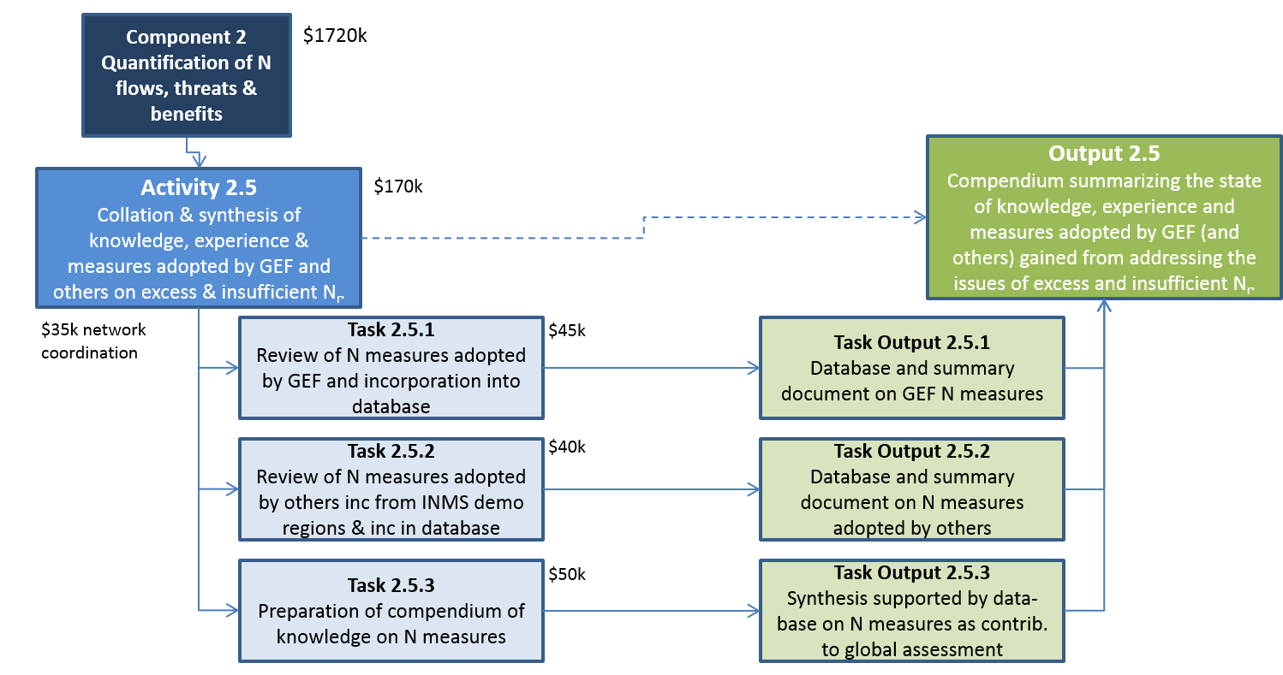

Figure A16.5: Summary of Tasks and Task Outputs needed to reach the overall Output in relation to exploration of future N storylines & scenarios with management/ mitigation options & cost-benefit analysis (Activity 2.5; Output 2.5).

Budget

GEF Budget
The overall budget for Component 2 is summarized in Table A16.2 below according to the standard UNEP cost codes. This is followed by a detailed breakdown of costs by year for each of the Activities 2.1 to 2.6. An additional activity is identified that allows for technical inputs at the level of Component 2 as a whole to ensure integration.

Table A16.2: Budget overview for Component 1: Tools and Methods for the Nitrogen Cycle (totals by Activity).

Table A16.3: Budget for Activity 2.1 Quantifying N flows, threats and benefits at global and regional scales (costs by year).

Table A16.4: Budget for Activity 2.2 Preparation of global assessment of N fluxes, pathways and impacts assimilating lessons from the regional demonstrations (costs by year).

Table A16.5: Budget for Activity 2.3 Integrating methods, measures & good practices to address issues of excess & insufficient reactive nitrogen (costs by year).

Table A16.6: Budget for Activity 2.4 Exploration of future N storylines & scenarios with management/ mitigation options & cost-benefit analysis (costs by year).

Table A167: Budget for Activity 2.5 Collation & synthesis of knowledge, experience & measures adopted by GEF and others on excess & insufficient reactive nitrogen (costs by year).

Table A16.9: Budget for Activity 2.0 Component Leadership: Quantification of N flows, threats & benefits (costs by year).

Table A16.10: Budget overview for Component 1: Tools and Methods for the Nitrogen Cycle (costs by year).

Co-financing
Information collected and tables to be compiled.

Component work-plan and timeline

Timeline
Component 2 operates throughout the duration of the project. Initial building of the work teams, preparatory reviews and cooperation with Component 1 are key aspect for Year 1, providing the basis to develop and apply the agreed approaches in Year 2 and Year 3. Year 4 focuses primarily on completion and consolidation of final messages especially in engagement Components 3 and 4. The activity work-plans show the detailed timing.

Activity Work-plans

M = Meeting, R= Report (includes other publications), W = Workshop,
[Clare: I did not use the following headings for Component 1: S = Communication Strategy, MR = Mid-term Report, TR = Terminal Report, I = Project website]

Activity 2.1 Quantifying N flows, threats and benefits at global and regional scales | Year 1 |  |  |  | Year 2 |  |  |  | Year 3 |  |  |  | Year 4
 | Q1 | Q2 | Q3 | Q4 | Q 1 | Q2 | Q3 | Q4 | Q 1 | Q2 | Q3 | Q4 | Q 1 | Q2 | Q3 | Q4
Task 2.1.1 Database of shared input, model outcomes & access to measurements |  | W |  | R |  | R
Task 2.1.2 International support to regional inventories & model application |  | M |  |  |  | R |  |  |  | R |  |  |  | R
Task 2.1.3 Combined analysis of present N flows and impacts at global and regional scales |  |  |  |  |  | W |  |  |  | R |  |  |  | R
Task 2.1.4 Quantifying present & future N threats & benefits at global and regional scales |  | M |  |  |  | M |  |  |  | W |  |  |  | M
Monitoring and Evaluation |  |  |  |  | R |  |  |  | R |  |  |  | R |  |  | W

Activity 2.2 Preparation of global assessment of N fluxes, pathways and impacts assimilating lessons from the regional demonstrations | Year 1 |  |  |  | Year 2 |  |  |  | Year 3 |  |  |  | Year 4
 | Q1 | Q2 | Q3 | Q4 | Q 1 | Q2 | Q3 | Q4 | Q 1 | Q2 | Q3 | Q4 | Q 1 | Q2 | Q3 | Q4
Task 2.2.1 Preparation of scope & structure of consolidated global assessment |  | WR
Task 2.2.2 Commissioning of author teams and preparation of the consolidated overview |  | M |  |  |  | W |  |  | W | W
Task 2.2.3 Peer review of chapters in the global assessment & revision |  |  |  |  |  |  |  |  | M
Task 2.2.4 Preparation of summary docs & review with workshop |  |  |  |  |  |  |  |  |  |  |  |  | W
Task 2.2.5 Publishing & distribution of consolidated assessment |  |  |  |  |  |  |  |  |  |  |  |  |  |  |  | R  W
Monitoring and Evaluation |  |  |  |  | R |  |  |  | R |  |  |  | R |  |  | R

Activity 2.3 Integrating methods, measures & good practices to address issues of excess & insufficient Nr | Year 1 |  |  |  | Year 2 |  |  |  | Year 3 |  |  |  | Year 4
 | Q1 | Q2 | Q3 | Q4 | Q 1 | Q2 | Q3 | Q4 | Q 1 | Q2 | Q3 | Q4 | Q 1 | Q2 | Q3 | Q4
Task 2.3.1 Preparation of documents on state of the art for N good practices (N form, N effects etc) |  | W |  | R
Task 2.3.2 Workshop to link methods & good practices for N effects (food, water, air, climate etc) |  |  |  |  |  | W | R
Task 2.3.3 Publishing of revised papers and preparation of synthetic guidance document |  |  |  |  |  |  |  |  |  | R
Task 2.3.4 Peer and Stakeholder review of Synthetic N guidance document |  |  |  |  |  |  |  |  |  |  |  | W
Task 2.3.5 Publishing of synthesis doc & updating of practice database |  |  |  |  |  |  |  |  |  |  |  |  |  |  |  | R
Monitoring and Evaluation |  |  |  |  | R |  |  |  | R |  |  |  | R |  |  | R

Activity 2.4 Exploration of future N storylines & scenarios with management/ mitigation options & cost-benefit analysis | Year 1 |  |  |  | Year 2 |  |  |  | Year 3 |  |  |  | Year 4
 | Q1 | Q2 | Q3 | Q4 | Q 1 | Q2 | Q3 | Q4 | Q 1 | Q2 | Q3 | Q4 | Q 1 | Q2 | Q3 | Q4
Task 2.4.1 Review of existing N policies for different countries & regions |  | M |  | R | M
Task 2.4.2 Review of existing storylines and scenarios relevant for N |  | M |  | R | M
Task 2.4.3 Workshop on N storylines & scenarios for shared use across the project |  |  |  |  |  |  | W | R
Task 2.4.4 Synthesis of future programmes and policy options supported by cost benefit analysis |  |  |  |  |  |  |  |  | M |  |  |  | R
Monitoring and Evaluation |  |  |  |  | R |  |  |  | R |  |  |  | R |  |  | R

Activity 2.5 Collation & synthesis of knowledge, experience & measures adopted by GEF and others on excess & insufficient Nr | Year 1 |  |  |  | Year 2 |  |  |  | Year 3 |  |  |  | Year 4
 | Q1 | Q2 | Q3 | Q4 | Q 1 | Q2 | Q3 | Q4 | Q 1 | Q2 | Q3 | Q4 | Q 1 | Q2 | Q3 | Q4
Task 2.5.1 Review of N measures adopted by GEF and incorporation into database |  | M |  | R
Task 2.5.2 Review of N measures adopted by others inc from INMS demo regions & inc in database |  |  |  |  | M |  | R
Task 2.5.3 Preparation of compendium of knowledge on N measures |  |  |  | R | M |  |  |  | R
Monitoring and Evaluation |  |  |  |  | R |  |  |  | R |  |  |  | R |  |  | R

Execution arrangements

The involvement of partners in each component and activity is based on their expressed commitments to the project. Leadership of Components and Activities will be confirmed by the General Assembly or amended at the start of the project. Figure A16.x shows the provisional organogram used to prepare the project, subject to this confirmation.

Figure A16.6: Organogram of Component 2.

Component M&E

The day-to-day monitoring of the activities of Component 2 of the INMS Project will be conducted by NERC, in collaboration with the Component, Activity and Task Leaders, under the supervision of the Project Manager. NERC will be responsible and co-ordinate the delivery of the monitoring and evaluation reports required by UNEP and the GEF in accordance with agreed dates, in addition to the internal needs of progress reporting to the Project Board and General Assembly.
The overall expectations of Component 2 is presented in the annex to this component with indicators and targets for delivery. These indicators will also be used to establish mid-term and end-of-project targets to enable the relevant external project evaluations to be completed. The proposed mid-term and end-of-project targets are given below in Table A16.10.

Table A16.10: Indicators to support Monitoring and Evaluation of Component 2. (Table under development but included here to show the flavour of what is required and being developed)
Project objective Outcomes & Outputs | Description of indicator | Baseline level | Mid-term target | End-of-project target
Activity 2.1 Quantifying N flows, threats and benefits at global and regional scales
Task 2.1.1 Database of shared input, model outcomes & access to measurements | INMS data plan (internal and external) developed, agreed and implemented.  Internal INMS database established and training provided.  Linking of external data in ENCORE data cluster, where possible. | 0  0  ENCORE data cluster already linked to project data (EU FP6 NEU & EU FP7 ECLAIRE). | Review of existing data sources and locations completed.  INMS database ready for upload and download, training provided to partners.  Report on status of relevant external INMS datasets which are linked through ENCORE and future plans. | Metadata for INMS relevant datasets collected and published on INMS website, for all internal, and external linked datasets (and external un-linked) .  Archiving of key datasets within the INMS database.  Key external datasets linked to ENCORE data cluster.
Task 2.1.2 International support to regional inventories & model application
Task 2.1.3 Combined analysis of present N flows and impacts at global and regional scales

Task 2.1.4 Quantifying present & future N threats & benefits at global and regional scales
Activity 2.2 Preparation of global assessment of N fluxes, pathways and impacts assimilating lessons from the regional demonstrations
Task 2.2.1 Preparation of scope & structure of consolidated global assessment
Task 2.2.2 Commissioning of author teams and preparation of the consolidated overview
Task 2.2.3 Peer review of chapters in the global assessment & revision
Task 2.2.4 Preparation of summary docs & review with workshop
Task 2.2.5 Publishing & distribution of consolidated assessment
Activity 2.3 Integrating methods, measures & good practices to address issues of excess & insufficient Nr
Task 2.3.1 Preparation of documents on state of the art for N good practices (N form, N effects etc)
Task 2.3.2 Workshop to link methods & good practices for N effects (food, water, air, climate etc)
Task 2.3.3 Publishing of revised papers and preparation of synthetic guidance document

Task 2.3.4 Peer and Stakeholder review of Synthetic N guidance document
Task 2.3.5 Publishing of synthesis doc & updating of practice database
Activity 2.4 Exploration of future N storylines & scenarios with management/ mitigation options & cost-benefit analysis
Task 2.4.1 Review of existing N policies for different countries & regions
Task 2.4.2 Review of existing storylines and scenarios relevant for N
Task 2.4.3 Workshop on N storylines & scenarios for shared use across the project
Task 2.4.4 Synthesis of future programmes and policy options supported by cost benefit analysis
Activity 2.5 Collation & synthesis of knowledge, experience & measures adopted by GEF and others on excess & insufficient Nr
Task 2.5.1 Review of N measures adopted by GEF and incorporation into database
Task 2.5.2 Review of N measures adopted by others inc from INMS demo regions & inc in database
Task 2.5.3 Preparation of compendium of knowledge on N measures

Annex 1 – Component Results Framework

Component 2 Quantification of N flows, threats & benefits
Outcomes and Outputs | Indicator | Baseline | Target | Sources of Verification | Assumptions
Outcome 2.1: Regional and Global information on N cycle fluxes and impacts, enabling strategies to be implemented to minimise negative effects of excess or insufficient reactive N, while maximising the quantified co-benefits for other sectors including the Green Economy | Number of new strategies at national, regional or global level to mitigate excess or insufficient N_{r} using information from INMS | Current policies based on fragmented approach and facing major barriers to change.  No coordinated source of information on the global nitrogen cycle for application in policies | 10 countries using INMS approaches and information to support their national policies  5 countries working on developing integrated nitrogen strategies using INMS resources | - National plans and documentation  - Documentation shared through multilateral environmental agreements
Output 2.1: Quantification & assessment of the regional threats from excess N and insufficient N | Data and reports to support regional demonstrations  Use of INMS results informing decision making by policy, business and civil society | Lack of agreement on approaches.  Lack of globally coherent picture across the nitrogen cycle and its multiple impacts. | - Support to regional demos with inventory expertise and models  - Demonstrated comparison of current situation and future scenarios for N threats and benefits  - Regional/global approaches incorporated into high profile global assessment | - High visibility global assessment delivered.  - Guidance documentation on N management delivered  - Costs benefit analysis delivered  - Modelling results reported for present and future conditions  - Independent documentation shows take up of results
Output 2.2: Detailed overview of regional/local N flux and consolidation into a global assessment of N fluxes and pathways | Completion of regional assessments of N fluxes, including impacts and lessons from demos | Some regional assessments existing, but not available for most regions. | - Agreed scope & outline of global assessment of N fluxes etc.  - Commissioned experts delivered high quality chapters passing peer review  - Review of chapters by SPAG, GA and other stakeholders (Yr. 4)  - Global assessment report published for wider public dissemination (Yr 4) | - Scoping document shared with partners and external review  - Assessment chapters delivered for peer review  - Modelling and scenario outcomes and delivered and reported  - Body of evidence on success stories and challenges shared  - At least 5 international policy processes using the results
Output 2.3: Consolidation of methods and good practices to address issues of excess and insufficient nitrogen | Specific reports published to support addressing excess and insufficient N | Available guidance documentation only available for fragmented sets of issues, N forms and effects | - Background docs for workshop (Year 2)  - Workshop (50 participants) methods for N management and mitigation (Yr 3)  - Consolidated methods/practices report & database published (Yr 4) | - Documentation delivered  - Users applying documentation as demonstrated by their own documentation
Output 2.4: Definition of programmes and policy options for improved Nr management at local/regional/global levels, supported by cost-benefit analysis to underpin options for the Green Economy. | Specific reports published on future N scenarios with mitigation options | Current programmes have little awareness of the links between themselves and other parts of the nitrogen cycle.  Fragmentation is a significant contributor to the barriers to change. | - Background docs for workshop (Yr. X)  - Workshop (80 participants) on N policies and scenarios completed & reported (Yr 3)  - Published report on N policy options & contribution to Green Economy (Yr 4) | - Documentation delivered  - Users applying results as demonstrated by their own processes.
Output 2.5: Compendium summarizing the state of knowledge, experience and measures adopted by GEF (and others) gained from addressing the issues of excess and insufficient Nr | Published reports  Level of awareness of key successes as well of failures and lessons learned. | STAP report 2011 on eutrophication  LRTAP assessment report  Examples brought togerther through the GNC project  Little awareness of bi-lateral programmes and successes by wider global community. | - Summary (inc. database) of GEF N management measures (Yr 1)  - Summary (inc. database) of non-GEF N management measures (Yr 2)  - Compendium of measures for effective N management published (Yr 3) | - Documentation delivered  - Results incorporated into global assessment report and INMS communication documentation

Annex 2 - Terms of Reference for Partners and Consultants
To be completed

Sutton M.A., Bleeker A., Howard C.M., Bekunda M., Grizzetti B., de Vries W., van Grinsven H.J.M., Abrol Y.P., Adhya T.K., Billen G.,. Davidson E.A, Datta A., Diaz R., Erisman J.W., Liu X.J., Oenema O., Palm C., Raghuram N., Reis S., Scholz R.W., Sims T., Westhoek H. & Zhang F.S., with contributions from Ayyappan S., Bouwman A.F., Bustamante M., Fowler D., Galloway J.N., Gavito M.E., Garnier J., Greenwood S., Hellums D.T., Holland M., Hoysall C., Jaramillo V.J., Klimont Z., Ometto J.P., Pathak H., Plocq Fichelet V., Powlson D., Ramakrishna K., Roy A., Sanders K., Sharma C., Singh B., Singh U., Yan X.Y. & Zhang Y. (2013) Our Nutrient World: The challenge to produce more food and energy with less pollution. Global Overview of Nutrient Management. CEH Edinburgh, on behalf of GPNM and INI. 114 pp.
Smith, B.P., Burns, P. & Reading, S. (2013) Communicating ‘Our Nutrient World’ – a report for UNEP (Published 18 February 2013). March 2013. Centre for Ecology & Hydrology 12 pp. See also Sutton M.A., Howard C.M., Bleeker A. and Datta A. (2013) The global nutrient challenge: From science to public engagement. Environmental Development 6, 80-85.
Bouwman AF, Klein Goldewijk K, van Der Hoek KW, Beusen AHW, van Vuuren DP, Willems J, Rufino MC, Stehfest E. (2013) Exploring global changes in nitrogen and phosphorus cycles in agriculture induced by livestock production over the 1900-2050 period. Proc. Natl. Acad. Sci. USA 110, 20882–20887.
Dentener F, Drevet J, Lamarque JF, Bey I, Eickhout B, Fiore AM, Hauglustaine D, Horowitz LW, Krol M, Kulshrestha UC, Lawrence M, Galy-Lacaux C, Rast S, Shindell D, Stevenson D, Van Noije T, Atherton C, Bell N, Bergman D, Butler T, Cofala J, Collins B, Doherty R, Ellingsen K, Galloway J, Gauss M, Montanaro V, Müller JF, Pitari G, Rodriguez J, Sanderson M, Solmon F, Strahan S, Schultz M, Sudo K, Szopa S, Wild O. (2006) Nitrogen and sulfur deposition on regional and global scales: A multimodel evaluation. Glob. Biogeochem. Cycles 20, GB4003.
Alkemade R, van Oorschot M, Miles L, Nellemann C, Bakkenes M, ten Brink B. GLOBIO3 (2009) A Framework to Investigate Options for Reducing Global Terrestrial Biodiversity Loss. Ecosystems 12, 374-390.
Fleischer, K., D. Wårlind, M. van der Molen, K. Rebel, A. Arneth, J.W. Erisman, M. Wassen, B. Smith, C. Gough, H. Margolis, A. Cescatti, L. Montagnani, A. Arain and H. Dolman (2015) Low historical nitrogen deposition effect on carbon sequestration in the boreal zone. Journal of Geophysical Research – Biogeosciences. DOI: 10.1002/2015JG002988.
Mayorga E, Seitzinger SP, Harrison JA, Dumont E, Beusen AHW, Bouwman AF, Fekete BM, Kroeze C, van Drecht G. (2010) Global Nutrient Export from WaterSheds 2 (NEWS 2): Model development and implementation. Environmental Modelling and Software 25, 837-853.
Sutton M.A., Howard C., Erisman J.W., Billen G., Bleeker A., Grennfelt P., van Grinsven H. and Grizzetti B. (2011) The European Nitrogen Assessment: Sources, Effects and Policy Perspectives (Eds.) Cambridge University Press. 612 pp.
De Vries, W., Cellier P., Erisman J.W. and Sutton M.A. (2011) Assessment of nitrogen fluxes to air and water from site scale to continental scale (Eds). (NitroEurope Special Issue) Environ. Pollution, 159 (11), 3143-3268.
Suddick E.C., Whitney P., Townsend A.R. & Davidson E.A. (2012) The role of nitrogen in climate change and the impacts of nitrogen–climate interactions in the United States: foreword to thematic issue. Biogeochemistry, DOI 10.1007/ s10533-012-9795-z;
Davidson E.A., David M.B., Galloway J.N., Goodale C.L., Haeuber R., Harrison J.A., Howarth R.W., Jaynes D.B., Lowrance R.R., Nolan B.T., Peel J.L., Pinder R.W., Porter E., Snyder C.S., Townsend A.R. & Ward M.H. (2012) Excess nitrogen in the U.S. environment: trends, risks, and solutions. Issues in Ecology, Report Number 15, Ecological Society of America.
USEPA Science Advisory Board, Integrated Nitrogen Committee (2011) Reactive Nitrogen in the United States: An analysis of Inputs, Flows, Consequences, and Management Options. EPA-SAB-11-013. United States Environment Protection Agency.
Abrol Y.P., Raghuram N. & Chanakya H.N. (Eds.) (2008) Reactive Nitrogen in Indian Agriculture, Environment and Health. Current Science (Nitrogen Special Issue) 94, 1375-1477.
Fowler D., Pyle J.A., Raven J.A. and Sutton M.A. (2013) The global nitrogen cycle of the twenty-first century. Philosophical Transactions of the Royal Society, Series B. 368 (1621)
UNEP (2013) Drawing Down N₂O to Protect Climate and the Ozone Layer. A UNEP Synthesis Report. (Eds.: J. Alcamo, S.A. Leonard, A.R. Ravishankara and M.A. Sutton). United Nations Environment Programme, Nairobi.
FAO (2006) Fertilizer use by crop. FAO Fertilizer and Plant Nutrition Bulletin 17. Food and Agriculture Organization of the United Nations, Rome. [ISBN 978-92-5-105592-2]
Bittman, S., Dedina, M., Howard C.M., Oenema, O. and Sutton, M.A. (2014) (eds.) Options for ammonia mitigation: Guidance from the UNECE Task Force on Reactive Nitrogen. TFRN-CLRTAP, Centre for Ecology and Hydrology, UK. [ ISBN: 978-1-906698-46-1]
UNECE (2015) United Nations Economic Commission for Europe Framework Code for Good Agricultural Practice for Reducing Ammonia Emissions. United Nations Economic Commission for Europe, Geneva.
Nakicenovic, N. et al . (2006). Special Report on Emissions Scenarios. Working group III of the Intergovernmental Panel on Climate Change , Cambridge University Press, Cambridge, UK, 2000.
Carpenter, S.R., Pingali, P.L., Bennett E.M., Zurek, M.B. (eds.), 2005. Ecosystems and Human Well-Being: Scenarios , Volume 2, Findings of the Scenarios Working Group, Millennium Ecosystem Assessment . Island. Press, Washington DC.
van Vuuren, D.P., et al. (2011) The representative concentration pathways: an overview. Climatic Change 109, 5–31. doi:10.1007/s10584-011-0148-z.
Nakicenovic, N., Lempert, R.J., Janetos, A.C. (2014) A Framework for the Development of New Socio-economic Scenarios for Climate Change Research: Introductory Essay. Climatic Change 122, 351–361. doi:10.1007/s10584-013-0982-2.
Bouwman, L., et al. (2013) Exploring global changes in nitrogen and phosphorus cycles in agriculture induced by livestock production over the 1900–2050 period. PNAS 110, 20882–20887. doi:10.1073/pnas.1012878108.
Bodirsky, B.L., et al. (2014) Reactive nitrogen requirements to feed the world in 2050 and potential to mitigate nitrogen pollution. Nature Communications 5. doi:10.1038/ncomms4858.
Winiwarter, W., et al. (2013) Estimating environmentally relevant fixed nitrogen demand in the 21st century. Climatic Change 120, 889–901. doi:10.1007/s10584-013-0834-0.
Rockström, J., et al. (2009) A safe operating space for humanity. Nature 461, 472–475.
Steffen, W., et al. (2015) Planetary boundaries: Guiding human development on a changing planet. Science 1259855. doi:10.1126/science.1259855.

